
Banyule Health and Wellbeing Plan Priorities

2025-2029

Contents
Introduction 3
Integrating health and wellbeing 5
Our approach to health and wellbeing 7
Our improvement goals 9
Relationship with Victoria’s health and wellbeing priorities 9
First Nations in focus 12
Uplifting health equity 14
Engage the community 15
Embrace intersectionality 15
Promote health equity 15
Collaborate with partners 15
Monitor and evaluate progress 17
Banyule’s health and wellbeing priority areas 18
Building Respectful Communities 18
Lifelong Healthy Habits 24
Every Body Active 32
Healthy Planet, Healthy People 38
Social Connection with Purpose 45
Foundations of community health and wellbeing 49
Council’s health and wellbeing services 51
Leading plans and strategies 56
Key terms 64
References 70

Introduction
In accordance with the Public Health and Wellbeing Act 2008, all local councils in Victoria must address the health and wellbeing needs of their communities through a Public Health and Wellbeing Plan. This strategic plan outlines the council’s primary goals and priorities for safeguarding, enhancing, and promoting public health and wellbeing within the municipality. Additionally, councils are committed to meeting health and wellbeing planning requirements under the Gender Equality Act 2020 and the Climate Change Act 2017.
As a global citizen, Banyule aligns priorities to the United Nations Sustainable Development Goals (SDG), with a shared commitment to address a wide range of health issues and tackle health inequities.
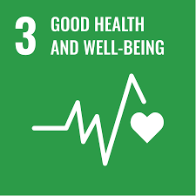 | Good Health and Well-Being  Council shares responsibility to create the foundations for healthy lives and promote wellbeing for all at any age. This includes initiatives to reduce disease, improve mental health and improve access to health care services.
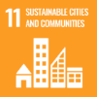 | Sustainable Cities and Communities  Council plays an important role in creasing sustainable, inclusive and resilient communities. By integrating health and wellbeing considerations into urban planning, we contribute to Goal 11, which focuses on making cities safe and sustainable.
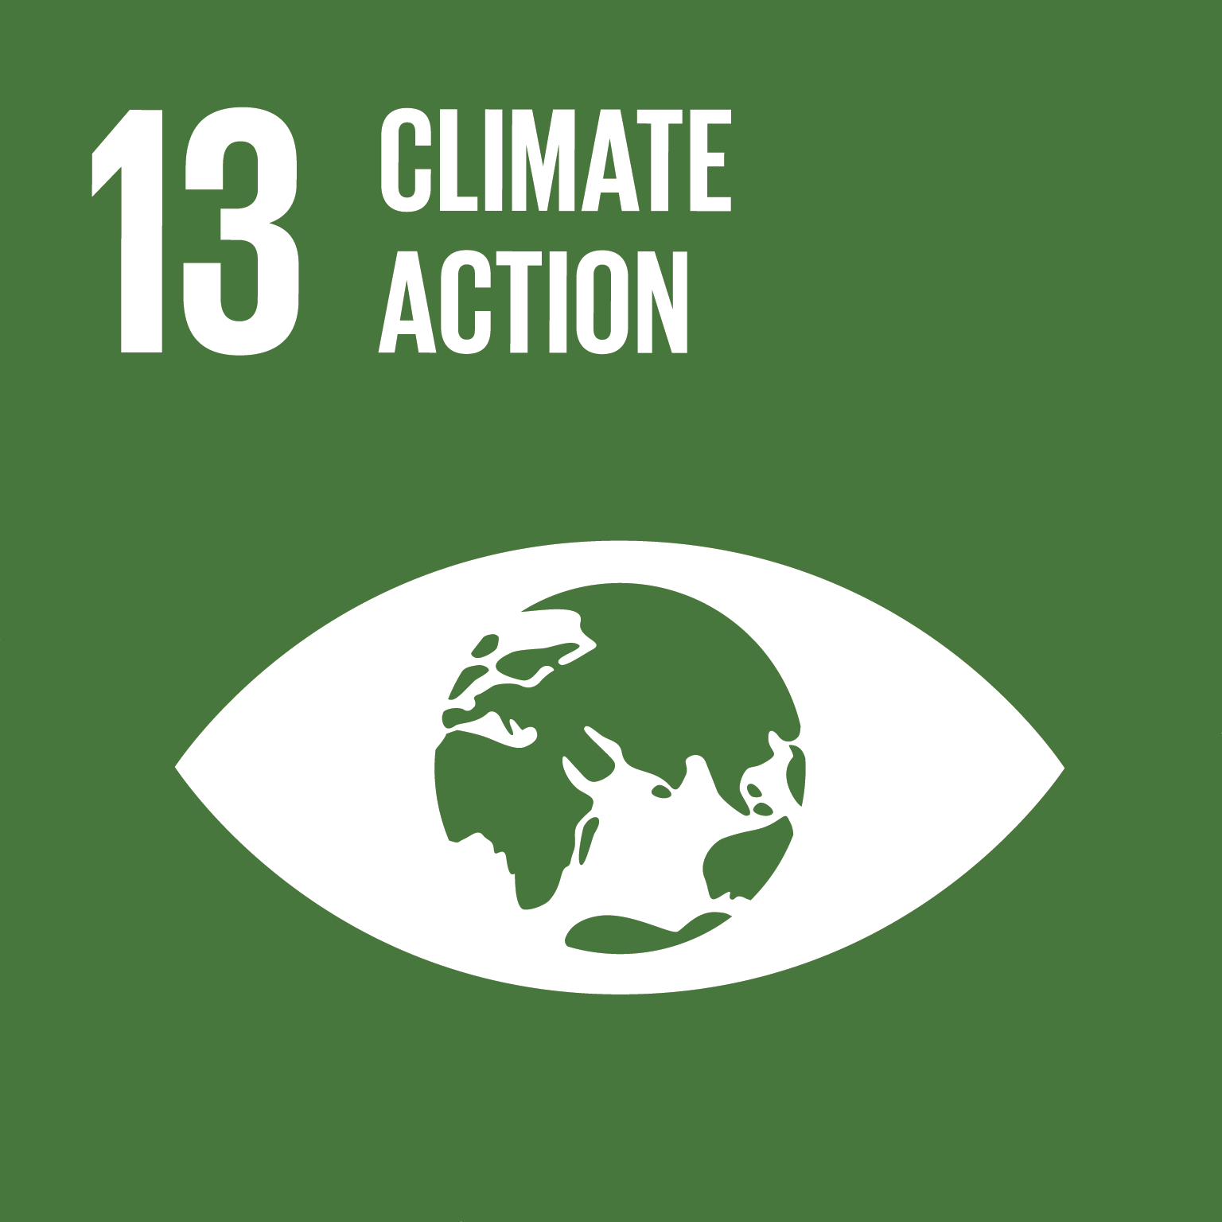 | Climate Action  The Healthy Planet, Healthy People priority address climate change, such as reducing pollution and promotion green spaces, supporting the SDG 13. These actions help mitigate health risks associated with environmental factors.
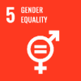 | Gender Equality  The Building Respectful Communities priority includes strategies to address gender disparities in health, supporting the SDG 5, which aims to achieve gender equality and empower all women and girls.
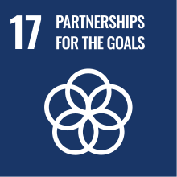 | Partnerships for the Goals  Council collaborates with various stakeholders, including health service providers, community groups and other government bodies, to achieve comprehensive health outcomes. This partnership approach supports Goal 17, which emphasises the importance of multi-stakeholder partnerships.

Integrating health and wellbeing
The Banyule Plan and Banyule Health and Wellbeing Plan priorities are interconnected.
- The Banyule Plan outlines the overall strategic direction and priorities for Banyule, covering a broad range of areas including infrastructure, community services, and economic development
- The Banyule Health and Wellbeing Plan specifically focuses on improving the health and wellbeing of the community
To amplify our impact, Banyule Council integrates the Health and Wellbeing Plan into the Banyule Plan 2025-2029.
Integration supports a more holistic and coordinated approach to improving public health and wellbeing in Banyule, ensuring that public health and wellbeing are prioritised across all council activities, leading to more comprehensive and effective actions.
The way in which the Banyule Health and Wellbeing Plan integrates with the Banyule Strategic Framework is outlined in Figure 2.

Figure : Banyule Strategic Planning and Reporting Framework (Below)

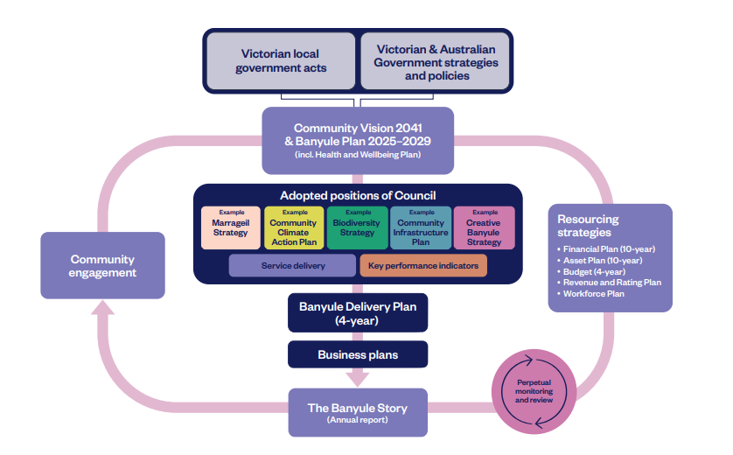

Our approach to health and wellbeing
Banyule’s Health and Wellbeing Plan considers key health and wellbeing data from sources including the Banyule Population Health Profile 2022, the Banyule Household Survey 2022, the Victorian Population Health Survey 2023, and the Banyule Living in Place Survey 2023. Our five priorities were shaped by community engagement data from the 2024 Banyule Futures consultation, and from the wisdom of our health and wellbeing partners across Banyule. Figure 2 shows a summary of the Banyule Health and Wellbeing Plan.

Figure 2: Health and Wellbeing plan on a page (below)
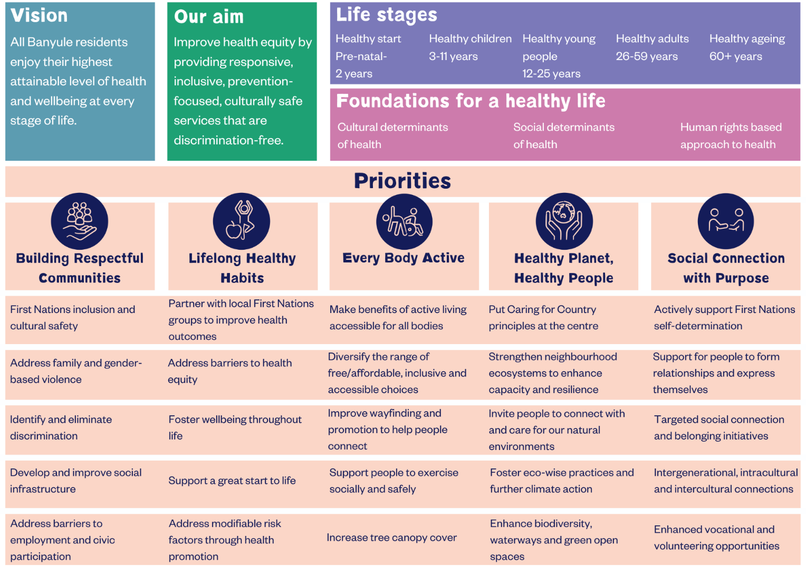

Our improvement goals
To address the root causes of health and wellbeing inequity, throughout the life of this plan we will:
- Invest in holistic First Nations health and wellbeing, with culture as the foundation
- Focus on biodiversity, healthy ecosystems and a stable climate as the foundations for achieving population level outcomes
- Place equity at the centre of the design, governance and implementation of preventative health and wellbeing across the life course
- Work with our partners to effect system-level change to address health equity barriers
- Focus on evidence-based continuous improvement and outcomes evaluation
- Invest in targeted and neighbourhood level actions that empower communities to design and deliver relevant, inclusive and unique local initiatives.

Relationship with Victoria’s health and wellbeing priorities
The Banyule Health and Wellbeing Plan outlines what we will do over the next four years to support individuals and communities to access what they need to improve their health and wellbeing.
Our priority areas are informed by the priorities described in the Victorian Health and Wellbeing Plan 2023-2027 and we aim to realise population level outcomes that can be measured against the Victorian Health and Wellbeing Outcomes Framework.
Figure 3: The Victorian public health and wellbeing plan 2023-2027 (below)

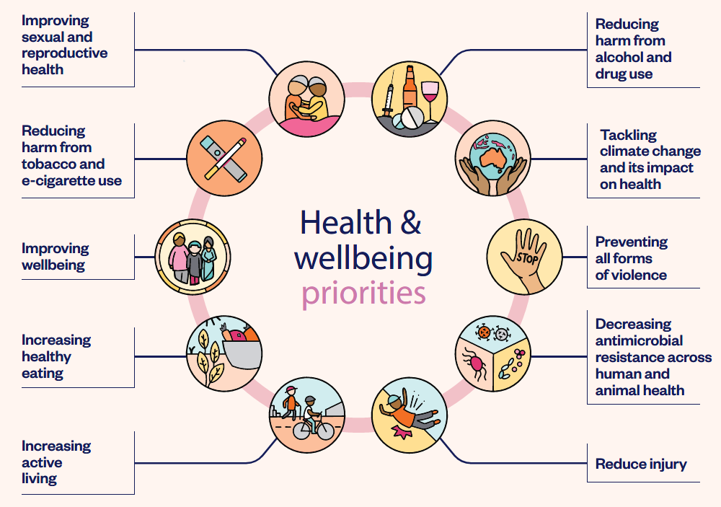

First Nations and the Victorian Public Health and Wellbeing Plan 2023-2027
Wellbeing for First Nations people is a holistic concept. Wellbeing is shaped by connections to culture, extended kinship, elders, ancestors, and spirituality, which in turn are influenced by social, historical, political, and cultural factors. Critically, this requires maintaining connection to Country and culture for Aboriginal Victorians.
Good health and wellbeing outcomes are not shared equally by all Victorians. A stronger focus on specific health issues faced by priority groups, and the systemic barriers they face to accessing health and wellbeing services, is needed to improve health equity. Racism and discrimination are key drivers of health inequities. For Aboriginal Victorians, these experiences are compounded by the impacts of colonialisation and trans-generational trauma.

First Nations in focus
At the heart of our reconciliation vision is the belief that including First Nations voices, values and principles into everything we do, will uplift the lives of First Nations community and our whole community.
Marrageil Strategy 2024-2031
Banyule City Council has an important role in supporting First Nations people’s health and wellbeing including social connection. It does this through supporting public health and community development programs in Banyule’s Health and Wellbeing Plan.
The Aboriginal Health and Wellbeing Partnership Forum (AHWPF) is the agenda-setting and decision-making body for Aboriginal Health in Victoria. The AHWPF has several strategic reform priorities with a focus on prevention.
We acknowledge that to ensure our plans and services are inclusive and respectful, it’s vital First Nations voices are considered and included. This means ensuring effective liaison between local Aboriginal-controlled health and wellbeing services including Barrbunin Beek Aboriginal Gathering Place. This is to draw on Aboriginal health, community leaders and Elders’ expertise and knowledge when designing and delivering services. Any health and wellbeing services provided to First Nations people, are to be culturally safe and free from racism.
We recognise that First Nations people’s health and wellbeing is foundational for thriving Aboriginal communities. That’s why we must develop strong partnerships with Aboriginal organisations and communities. Those partnerships are integral to improving health and wellbeing outcomes for Aboriginal Victorians. Particularly for First Nations women who are disproportionately over-represented in family violence statistics and have poorer employment outcomes.
Banyule City Council would like to thank all those who contributed to the establishment of these health and wellbeing priorities through the development of the Marrageil Strategy 2024-2031. With honourable mentions to:
- Wurundjeri Woi-wurrung Land Council
- Wurundjeri Woi-wurrung Land Council Cultural Consultations Unit
- Banyule City Council Reconciliation Action Plan Advisory Group
- Banyule City Council Self-Determination Working Group
- Barrbunin Beek Aboriginal Gathering Place Committee
- Local Aboriginal and Torres Strait Islander community
- Local Reconciliation groups
Closing the Gap: July 2024 update on health and wellbeing
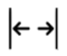
Life expectancy gap improving but not on track

Rates of death by suicide increasing and sustained reduction not on track

Higher proportions of babies are being born at a healthy birthweight and is on track

Proportion of children developmentally on track has declined and not on track

Uplifting health equity
Council is dedicated to fostering an inclusive and equitable community where every individual can thrive. We recognise that health and wellbeing outcomes are influenced by a complex interplay of social, economic, and environmental factors, whilst these factors can affect people differently based on their unique identities and experiences.
To assess health equity, Council produced the Banyule Population Health Profile. This report outlines community level data related to the ten (10) Victorian Health and Wellbeing priorities, key population segment profiles and other important health and wellbeing impacts.
Four key planning approaches inform the foundations of our work:
- Cultural determinants of health, highlighting the importance of culturally responsive health and wellbeing actions, that respect and respond to the needs of First Nations people. Cultural responsiveness also encompasses the wide range of diverse backgrounds that Banyule residents identify with
- Social determinants of health, considering factors such as education, housing, employment, socio-economic status and access to healthcare, and how they influence health and wellbeing outcomes and contribute to inequities across different population groups
- Human rights-based approach to health, ensuring all health and wellbeing actions respect, protect and fulfill the human rights of individuals. This approach emphasises social justice principles of access, equity, and participation, prioritises accountability and aims to eliminate discrimination while promoting the highest attainable standards of health and wellbeing for everyone
- Life stage approach to health and wellbeing, focusing on critical life stages and transitions:
- Early childhood (pre-birth to 5 years)
- Middle years (5 to 11 years)
- Young people (12 to 25 years)
- Adulthood (26 to 59 years)
- Older adults (60+ years).
Council’s role is to address health disparities with a focus on prevention and health promotion. Over the next four years we will:

Engage the community
We will actively involve community members in the planning, implementation, and evaluation of our health and wellbeing priorities. By listening to and valuing the voices of those with lived experiences, we can create more effective and meaningful solutions.

Embrace intersectionality
We will adopt an intersectional approach to understand how various aspects of identity—such as race, gender, age, disability, and socioeconomic status—intersect and impact health outcomes. This approach will guide our actions to ensure they are inclusive and responsive to the diverse needs of our community.

Promote health equity
We are committed to reducing health inequities by addressing the root causes of disadvantage and ensuring that all community members have access to the resources and opportunities they need to achieve optimal health. This includes maintaining social research and data reports on health inequity and delivering targeted initiatives to support vulnerable and marginalised groups.

Collaborate with partners
We all play an important part in addressing the root causes of a range of health and wellbeing issues that impact our community. Our collective voice and efforts are more powerful than individual efforts, and when we pool our resources, expertise and knowledge, we are better able to address complex health issues, influence policy and attract the services and supports our community need. When we work together to develop actions that address various health and wellbeing issues on a community-wide and localised scale, we are more likely to create significant, long-term outcomes.
Across our priority areas, Council will work with a range of partners including include health service providers, government bodies, Councils, community groups, and residents, with the aim of combining our efforts to support better health and wellbeing outcomes for everyone.
Through a commitment to long-term partnerships and collaborations, we will remain focused on a shared goals and coordination of efforts and resources over time.
Building Respectful Communities | Every Body Active | Healthy Planet, Healthy People | Lifelong Healthy Habits | Social Connection with Purpose
Women’s Health in the North | Belgravia Leisure and YMCA | Wurundjeri Woi-wurrung Land Council | Holstep Health, (inc. Gambler’s Help) | Neighbourhood Houses
Barrbunin Beek Aboriginal Gathering Place Committee | Sport and recreation clubs | People & Parks Foundation | Aboriginal Controlled Community Health Organisations | Yarra Plenty Regional Library
Brotherhood of St. Laurence |  |  | Banyule Support and Information Centre | U3A
Department of Education |  |  | Diamond Valley Community Support
Table 1: Identified health and wellbeing partners

Monitor and evaluate progress
We will establish clear metrics to track our progress in promoting intersectionality and health equity. Regular monitoring and evaluation will help us identify areas for improvement and ensure accountability in our efforts.
Our measurement approach includes:
- A framework of population level health and wellbeing Key Performance Indicators (KPI’s), across the five health and wellbeing priorities
- Engagement with community and partners, to ensure the priorities and objectives continue to reflect local priorities and values
- Quantitative and qualitative data analysis to measure the indicators, using government and health agency reports, community surveys and administrative data
- Monitoring through regular considerations of results and reporting to partners and the community through bi-annual and annual reports and a community dashboard
- Use of data for planning and decision making, with the aim of identifying areas for improvement and gaps, allocating resources, and evaluating the effectiveness of actions

Banyule’s health and wellbeing priority areas

Building Respectful Communities
Building Respectful Communities across Banyule is about creating a culture where everyone is treated with dignity and respect, leading to a safer, more inclusive and supportive community.

Why this is important
Respectful communities ensure that everyone, regardless of their background, feels valued and included. This is particularly important in a diverse society like Banyule, where people come from various cultural, linguistic, and social backgrounds. Respectful interactions build trust and cooperation among community members, leading to stronger, more resilient communities. This collective strength is essential for addressing common challenges and achieving shared goals.
Communities built on respect foster stronger bonds, promote sense of belonging and mutual support, which leads to improved social cohesion. A respectful environment contributes to better mental health and overall wellbeing. When people feel respected and valued, they are more likely to experience better mental wellbeing.
Respectful communities play a significant role in reducing family violence. By fostering respect and equity, we can address harmful behaviours and attitudes that lead to violence, and we promote safety and equality for everyone.
Teaching children the importance of respect and equity from a young age supports the development of healthy relationships, resilience and confidence, preparing them to navigate future challenges positively.
Addressing and preventing racism, ageism, ableism, gender inequity, LGBTIQA+ oppression and other forms of discrimination can mitigate the harmful direct and indirect effects on the health and wellbeing of our community.
What we know:
- Feeling safe is a top priority for 71% of Banyule residents when determining what makes a place liveable, ranking it as the most important aspect (Living in Place, 2023)
- There is a notable difference in safety perceptions across precincts: residents in the North Eastern suburbs rated their sense of safety at 7.8 out of 10, while those in the northern areas gave it a lower score of 5.3 out of 10. The average for Victoria is 7.1 out of 10 (Living in Place, 2023)
- 2.6% of overall of respondents said that they had experienced discrimination, abuse or social exclusion due to their ethnicity, for multi-lingual respondents this rate is higher at 8.3% (Banyule Household Survey, 2022)
- According to Victoria University Racism Research (2024), 73% of survey respondents from Banyule have experienced racism in Australia (themselves or someone in their care). Of those, 61% experienced racism in the past 12 months
- 71% of Australian adults over 65 reported that they had been insulted or mistreated based on their age (Australian Human Rights Commission, 2013)
Our community (have told us they) want:
- Safety and actions that promote inclusion, participation and equity
- Equitable interactions and opportunity to participate in community and civic life
- Lived experience is respected and actively listened to
- Festivals and events celebrating different cultures
- Education on cultural differences and respect in schools, workplaces and community program

What will we do
We will collaborate to advance Council’s efforts to become a leader in supporting an inclusive and connected community where everyone lives free from violence and discrimination and enables everyone to be who they want to be.
We will challenge racism and discrimination in all its forms and actively promote a diverse and inclusive community that respects and celebrates different cultures, beliefs, abilities, bodies, ages, sexualities, genders and identities. We will advocate for the prevention of all forms of gender-based and family violence, including through actions to address gender inequality within Council and across Banyule.
Objectives | What you will see
First Nations inclusion and cultural safety | - Actions that celebrate, protect and share Aboriginal history, heritage and culture  - Actions that address cultural safety concerns in community buildings and public spaces  - Strengthen relationships with local Aboriginal Community Controlled Organisations
Identify and eliminate discrimination | Actions that foster equity, including gender equity, respect and the prevention of all forms of discrimination and violence, with a focus on:  - Establishing multisector partnerships to drive action  - Strengthening equity safeguards and measures for communications, policies, processes and practices  - Embedding culturally inclusive practices across community settings to address stigma, racism and discrimination  - Educating individuals and communities to understand and address forms of discrimination including racism, ageism, ableism, gender inequity, LGBTIQA+ oppression, Indigenous discrimination and poverty  - Raising visibility, celebrating and build awareness of our diverse communities through supporting community led neighbourhood actions that encourage diverse communities to come together to learn, share culture, celebrate and foster social cohesion
Develop and improve our social infrastructure | - Improvements to our community infrastructure to ensure equitable, inclusive and safe access to our buildings, facilities and spaces  - Implement modifications to create universal accessible community buildings so they are fit for purpose, fit for people and fit for place  - Actions that address gender inequity across community settings
Address barriers to employment and civic participation | - Inclusive actions that address barriers to vocation and employment opportunities  - Coordinated partnership approach to improve the effectiveness of vocational, employment and civic participation pathways  - Actions that enhance pathways to employment, with a focus on meaningful experiences that increase knowledge and skills
Address family and gender-based violence | - Coordinated and culturally safe referrals and supports people at risk and victim survivors of family and gender-based violence, and all other forms of violence  - A coordinated approach to ensure the needs of victim survivors are centred in response frameworks  - Advocacy to State and Federal Governments to take necessary steps to provide local sustainable, appropriate housing, wrap-around services and access to material basics  - Actions aligned with Our Watch Change the Story approach to supporting men and boys to unpack masculinities and engage men the prevention practices  - Implementation of the 2023 Local Government guide for preventing family violence and all forms of violence against women, with a focus on actions that challenge and transform rigid ideas and practices about gender  - Coordinated implementation of active consent education across communities and sectors

How we will know we are on track
- Diverse community actions that foster positive relationships
- Positive trends in community satisfaction across Council services and programs
- Adaptations made to services, programs and events to improve access, equity, participation and uphold rights of people who experience barriers to inclusion

Connection to the Victorian public health and wellbeing plan 2023-2027
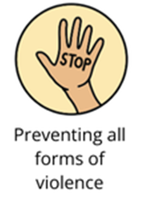 | Preventing all forms of violence  - Build a community-wide approach to preventing family, sexual and gendered violence to ensure every Victorian is treated equally with respect and dignity  - Victorians experiencing violence can access culturally safe supports and services that are free from stigma, racism and discrimination and are empowered to make decisions about their safety and wellbeing  - Work with men and boys to change attitudes and behaviours that can lead to violence and engage all Victorians in practical and creative ways to learn about respectful, safe and equitable relationships  - Embed Aboriginal-led prevention and responses to victim survivors of violence
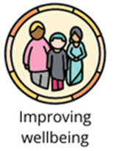 | Improving wellbeing  - Feeling safe and being respected for who we are

Lifelong Healthy Habits
By encouraging the establishment of Lifelong Healthy Habits, we can foster a healthier, happier and more sustainable future for all Banyule residents.

Why this is important
Healthy habits, including regular physical activity and balanced nutrition, are linked to better mental health. Communities that are healthy and well are more productive, resilient, socially connected and safe.
Adults who role model healthy habits offer a positive example for children and young people, which fosters a culture of health and wellbeing behaviours than spans generations. When healthy habits are established early in life, we see improvement in individual health outcomes, reduction in the risk of chronic disease and reduced impact on healthcare systems. Maintaining these healthy habits throughout life supports healthy ageing, including ongoing mobility, cognitive functions and independence.
What we know:
- Gambling losses in Banyule to electronic gaming machines approximated $57.2 million (Banyule Gambling Harm Prevention Policy, 2024-2028)
- 29.3% of Banyule adults consumed sugar-sweetened beverages daily or several times per week (Victorian Population Health Survey, 2023)
- 14% of Banyule adults smoked or vaped (Victorian Population Health Survey, 2023)
- 8.4% of Banyule adults were at risk of harm from alcohol-related disease or injury (Victorian Population Health Survey, 2023)
- 6.5% of adults in Banyule experienced food insecurity and 9.2% worried about food insecurity (Victorian Population Health Survey, 2023)
Our community (have told us they) want:
- Actions that tackle barriers to good health and wellbeing for children and young people
- Increased education programs to foster positive health behaviours
- New and varied communication methods that increase engagement in health messaging, with a focus on reaching diverse communities
- Opportunities to share knowledge between community members

What will we do
In partnership with the health sector, we will improve access to information, resources, and program supports that encourage our community to adopt lifelong healthy habits. Grounded in evidence-based approaches, we will address the barriers in systems and processes that lead to health inequity.
We will use our existing communication platforms, including our website and social media platforms to provide accurate and reliable information to the community about the services, programs and other opportunities available to people across Banyule. We will share health promotion messages with diverse communities.
We will build and strengthen relationships with community leaders and connectors to facilitate information sharing and knowledge exchange between communities, Council, and other local organisations.
Objectives | What you will see
Partnerships with local First Nations groups to improve health outcomes | - Partnership development with Barrbunin Beek Aboriginal Gathering Place Committee and Aboriginal-controlled health and wellbeing services  - Actions that support Aboriginal and Torres Strait Islander children to achieve their potential in the early years and to set them up for long-term success  - Actions that support First people to access health and wellbeing information and services that enable participation in informed decision-making regarding their own lives
Address modifiable risk factors through the delivery of health promotion initiatives | - Community capacity building actions across neighbourhoods that empower individuals to take control of their health and actively participation in their own health management  - Partnership with Women’s Health in the North that promotes sexually transmitted infection (STI) testing, to address the higher rates of STI’s in Banyule  - Partnerships that support residents to live independently longer and age well in place, including injury prevention  - Partnerships to address gambling harm, with a focus on banning gambling advertising  - Partnerships aimed at reducing harm from alcohol and other drugs, tobacco and vaping  - Actions that promote safe and accessible, active travel options  - Advocacy to address gaps in local primary prevention initiatives, with a focus on progressing gender equity and building respectful relationships  - Actions that promote the Cancer Council SunSmart campaigns  - Development of an approach to tackle the commercial determinants of health
Foster wellbeing throughout life | - Actions that promote health seeking behaviours by raising awareness and reducing the stigma of complex mental health  - Partnerships that prevent and respond to bullying and foster the safe use of social media  - Advocacy and actions that respond to the changing social media environment and support young people’s need to connect, access supports and belong  - Partnership with People & Parks Foundation to support ‘nature dosing’ and foster ‘nature wise’ practices  - Capacity building actions with community organisations to support people to enjoy the benefits of social prescribing
Support a great start to life | - Campaigns and actions that promote the benefits of breastfeeding and chestfeeding and supports for people’s individual journeys  - Continue to build on the INFANT program, to support families with healthy eating, active play and reduced screen time  - Early literacy and early education initiatives across community settings  - Implementation of Best Start, Best Life reforms across early childhood preschool programs  - Support to access early education through the delivery of the Early Years CALD outreach program  - Support for children 6-12 years to participate, connect, learn and belong in their local community  - Supports for young people to connect through the implementation of the Youth Spaces Plan  - Partnership actions focused on establishing early pathways to connect children and young people to health and wellbeing services and programs  - Actions that foster the civic participation of children and young people  - Actions that strengthen and further embed Child Safe practices across the organisation
Address barriers to health equity | - Actions that create sustainable, accessible food systems across Banyule  - Partnerships that tackle the commercial determinants of health and wellbeing, with a focus on measures that address products and practices responsible for escalating levels of preventable ill health  - Coordinated advocacy efforts with partners to address availability, accessibility, navigation and affordability of local health and wellbeing services. Focus areas include bulk-billed general practitioners and dentists, targeted mental health and wellness services, NDIS disability support, aged care and housing and homelessness services  - Health and wellbeing partnerships to attract health promotion services and resources to the community, that focus on health promotion  - Actions that address the supply of housing across communities, which accommodates the life stages, preferences, abilities and incomes in our communities  - Actions that progress a person-centred and coordinated approach to homelessness.

How we will know we are on track
- An increase in partnerships and collaboration with First Nations groups and organisations
- Increased delivery of health promotion initiatives with partners
- Delivery of initiatives that seek to improve mental health and wellbeing outcomes for the community
- Enhanced health and wellbeing outcomes for children and young people
- Reduced health disparities among different population groups in the community
Connection to the Victorian public health and wellbeing plan 2023-2027
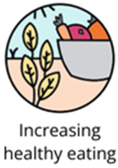 | Increasing healthy eating  - Increase access, availability and consumption of a wide variety of nutritious foods such as fruit and vegetables, as recommended by the Australian Dietary Guidelines  - Prioritise implementation of policies that promote the uptake of healthy foods and drinks in key public settings (including health services, schools, early childhood services, workplaces, sport and recreation settings and events)  - Reduce children’s exposure to marketing of discretionary foods and drinks to reduce consumption  - Promote healthy and more equitable, sustainable food systems across Victoria, with a focus on priority populations  - Scale evidence-based approaches that promote breastfeeding and support parents and caregivers to provide good nutrition for infants and young children throughout their first 2,000 days of life
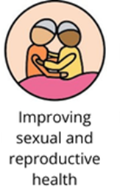 | Improving sexual and reproductive health  - Support Victorians to access culturally safe sexual and reproductive health services that are free from stigma, racism and discrimination  - Strengthen the sexual and reproductive health of Victorian women, girls and gender diverse people across the life course, with a focus on areas such as menstrual health, contraception, abortion and assisted reproductive treatment  - Support Victorians to achieve optimal sexual and reproductive health and reduce the transmission and impact of blood-borne viruses and sexually transmitted infections
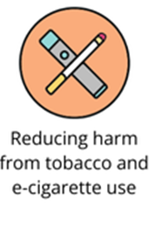 | Reducing harm from tobacco and e-cigarette use  - Prevent the uptake and reduce the harms associated with smoking and vaping, including second-and-third-hand exposure, through ongoing support and strengthening tobacco and e-cigarette regulation in Victoria
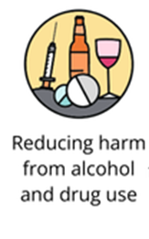 | Reducing harm from alcohol and drug use  - Offer safe and accessible treatment options that are responsive to individual needs and support better outcomes for people and their communities
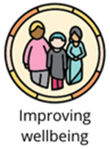 | Improving wellbeing  - Having our basic needs met before we can focus on other aspects of wellbeing

Every Body Active
Regardless of age, identity or ability, being physically active improves overall health and wellbeing, and exercising together fosters social connections and helps build a sense of community.

Why this is important
Being physically active from a young age is crucial for healthy growth and development, supporting motor skills, coordination and thinking. Being active improves sleep, increases energy levels and fosters a sense of wellbeing. Regular physical activity strengthens bones and muscles and reduces the risk of falls, injuries and of developing chronic diseases, boosts our mood and reduces symptoms of depression, anxiety and supports stress management.
What we know:
- 38% of Banyule adults undertake at least 150 minutes of moderate to vigorous physical activity per week (Victorian Population Health Survey, 2023)
- Perceptions of good physical health decreases with age. After 60 years of age, participation in physical activity declines rapidly (Australian Institute of Health and Welfare, 2023)
- For a range of people, barriers including physical accessibility, physical, psychological and cultural safety and affordability inhibit opportunities to be physically active (Australian Institute of Health and Welfare, 2023)
Our community (have told us they) want:
- Equitably available sports and recreation resources
- Upgrades to parks, newly created walking tracks, crossing points and bike lanes, and maintained ovals and playgrounds
- Innovative opportunities to increase activity, social connection and strengthen community spirit
- Plans that consider the needs of ageing population, as well as children and young people
- More low cost, gentle exercise and connections to nature for all abilities
- Better connectivity of existing parks and tracks with public transport

What will we do
Whilst building on the quality of our established sports, recreation and aquatic facilities in the municipality, our goal is to support more people to be more active across more community settings, from neighbourhood houses to the great outdoors.
We will reduce barriers to participation by providing a diverse and engaging range of activities inside and through our parks, opens spaces and natural environments and improving inclusion practices across settings.
Supported by our partners, we will endeavour to support any body to be active in ways that suit their individual needs and aspirations, with a focus on low cost or free gentle exercise programs in accessible and safe locations.
With this focus, we aim to improve our community’s physical and mental health, encourage social inclusion, support mobility, independence, and quality of life for individuals of all ages and abilities.
Objectives | What you will see
Make the benefits of active living accessible for all bodies | - Actions that encourage and support First Nations people’s inclusion in active living opportunities  - Continued investment in well maintained, safe active infrastructure, including leisure centres, sports pavilions and ovals, parks, walking trails, bike lanes and play spaces so they are fit for people, fit for purpose and fit for place  - Strategies that build the capacity of sporting facilities, clubs and community-based organisations to enhance their welcoming and inclusive culture, with a focus on cultural and psychological safety  - Strengthened collaborative partnership actions that deliver benefits for people who need support to be active in Banyule, with a focus on support to participate  - Campaigns that promote the adoption of regular active living routines including walking and cycling, with a focus on older adults, children and young people
Diversify the range of free/affordable, inclusive and accessible choices | - Actions that invite the sustainable use of natural and open spaces for active living, with a focus on affordability and accessibility  - Partnerships with community organisations to plan and deliver free/ affordable, inclusive and accessible choices
Improve wayfinding and promotion to help people connect | - Actions that improve the connectivity of active and public transport routes across Banyule and beyond  - Wayfinding and other communication actions that connect people to active living opportunities  - Actions to create accessible, safe and better-connected public transport routes, with a focus on improving accessibility at transport hubs and activity centres
Increase tree canopy cover | - Progress towards achieving the 2050 target for tree canopy cover
Support people to exercise socially and safely | - More low impact physical activity spaces with playable elements across neighbourhoods  - Actions that invite groups of people to come together to exercise  - Campaigns that encourage SunSmart behaviours

How we will know we are on track
- Increase participation in active living activities and programs by a diverse range of bodies, abilities, ages, sexualities and genders
- Reduced reliance on private vehicles
- Increased canopy cover
- Increased awareness of local active living opportunities
- Increased level of satisfaction in Council’s active living programs and infrastructure

Connection to the Victorian public health and wellbeing plan 2023-2027
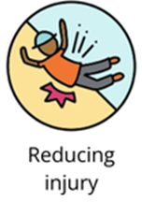 | Reducing injury  - Align action with national and statewide strategies, evidence-based interventions and best practice guidance to prevent falls and falls-related injury and promote healthy and active ageing
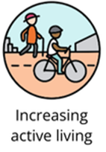 | Increasing active living  - Integrate healthy design principles into land-use planning to ensure improved health and wellbeing by increasing levels of physical activity through active transport modes, such as walking and riding  - Increase participation in sport and active recreation, with focus on Victorians who face barriers to participation  - Improve safe access to parks, public open spaces and recreation opportunities in nature and provide opportunities for Victorians to connect with nature.  - Promote movement and reduce sitting time in workplaces, schools, at home and during leisure time
Improving wellbeing
- Feeling connected to each other, our communities, cultures and spaces around us
- Feeling safe and being respected for who we are

Healthy Planet, Healthy People
Integrating natural environments into daily living can lead to a happier, healthier and more connected community and connecting with nature fosters behaviours that protect and preserve the natural environment.

Why this is important
Access to green spaces and natural environments promotes relaxation, mental wellbeing and can foster social interactions, which can reduce feelings of loneliness and isolation. Exposure to nature has been shown to improve cognitive functions, including attention, memory and creativity. Banyule’s natural environments encourage physical activity, which is essential for maintaining physical health.
Connecting with nature fosters a sense of environmental stewardship and awareness. People who spend time in natural settings are more likely to engage in behaviours that protect and preserve the environment, critical for the health of our plant and all people. Natural environments, including our green urban spaces, help mitigate the effects of climate change by reducing urban heat islands, and managing stormwater. This contributes to a healthier and more resilient urban environment, critical for the health of our planet and all life on earth.
What we know:
- Access to the natural environment is important to 66% of Banyule residents (Living in Place, 2023)
- 72% of Victorians are concerned the impacts of climate change (Sustainability Victoria, 2023)
- 91% of parents believe it's important that their children spend time in nature (Meis-Harris et al. 2019)
- Older Victorians are more connected to nature than younger Victorians (Meis-Harris et al. 2019)
- 30% of responses indicated that climate change impacts their mental and physical health (Banyule Community Emissions Reduction Plan Community Engagement, 2019)
Our community (have told us they) want:
- The physical environment was one of the strongest community consultation themes, where residents emphasised the importance of access to open and green space to improve their health and wellbeing
- Concern regarding the impact of development on the natural environment

What will we do
We will deliver a human rights approach to climate change, fostering a fairer distribution of the burdens and benefits. We will do this by addressing the harm and inequalities people experience because of where they live, gender, socio-economic status, age and identity.
We will recognize the disproportionate impact of climate extremes on people in our community (e.g. those living with disability, older people and people experiencing poverty) and address this through the ongoing work in climate change and climate adaptation.
We will protect and enhance our natural environment by protecting local ecosystems, connecting natural habitats and maintaining Banyule’s urban forest population.
We will improve safe access to parks, public open spaces and recreation opportunities in nature.
We will provide strong leadership to address climate change, including by empowering communities and businesses to take actions that protect the environment and reduce emissions.
We will foster regular and strong connections between people and nature to support better health and wellbeing and to encourage awareness and protection of our natural environment.
Objectives | What you will see
Put Caring for Country principles at the centre | - Increase education to the community about Traditional knowledge of land management practices and native/indigenous plants  - Embed Caring for Country principles across all of Council core business
Enhance biodiversity, waterways and green open spaces | - Partnerships to protect natural spaces and waterways  - Actions that support the implementation of the Biodiversity Strategy, Public Open Spaces Plan, Urban Forest Strategy, Integrated Water Management Plan and Public Realm Framework  - Partnership with People & Parks Foundations to build the Nature-wise Banyule program
Invite people to connect with and care for our natural environments | - Partnership with People & Parks Foundation to support people to experience the health and wellbeing benefits of connecting to nature  - Opportunities to connect with nature through the community programs like the Spring Outdoors program  - Actions that support Friends of Groups to take a lead on caring for natural environments  - Actions that invite communities to value, protect and plant trees  - Partnerships that continue the Gardens for Wildlife program  - Actions that help community gardens to thrive  - Actions that support people to reduce the detrimental impacts of waste on the natural environment
Foster eco-wise practices and further climate action | - Partnerships that foster the adoption of environmentally friendly business practices  - Implementation of Biodiversity Sensitive Urban Design into future planning of Banyule  - Education and capacity building of individuals and community on climate adaptation approaches to support wellbeing, with a focus on equity informed climate adaptation  - Actions that assist community to achieve carbon neutrality by 2040  - Actions that support the redesign of food systems to be nature-positive  - Actions that support the community to avoid waste, reduce, repair, re-use, and recycle, to help Council achieve waste targets
Strengthen neighbourhood ecosystems to enhance capacity and resilience | - Actions that address vulnerability and risk, with a focus on the social and economic environment  - Actions that build and strengthen relationships with community leaders and connectors to facilitate knowledge exchange and mutual aid between communities, Council, and other local organisations  - Enhancements to our communication platforms, including our website and social media platforms, provide accurate and reliable information to the community about the services, programs and other opportunities available to people across Banyule

How we will know we are on track
- An increase in community programs and policies reflecting Indigenous knowledge and practices
- Higher biodiversity indices and increased coverage of green open spaces and healthy waterways
- An increase in community members participating in activities and programs that promote connection with and care for nature
- Increased community participation in sustainable practices and climate action initiatives
- Stronger local ecosystems with enhanced capacity to withstand environmental changes and challenges

Connection with the Victorian public health and wellbeing plan 2023-2027
Increasing active living
- Improve safe access to parks, public open spaces and recreation opportunities in nature and provide opportunities for Victorians to connect with nature
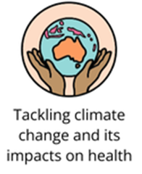 | Tackling climate change and its impacts on health  - Increase action to reduce greenhouse gas emissions across systems at the scale and pace required to reduce the impacts on health and wellbeing and realise associated health co-benefits  - Create resilient and safe communities that can adapt to the public health impacts of climate change  - Accelerate action to support communities to adapt to climate change and its impacts on health  - Share successes and promote good practice examples of climate action
Improving wellbeing
- Feeling connected to each other, our communities, cultures and spaces around us

Social Connection with Purpose
Social connections foster meaningful interactions between diverse groups and like-minded people, leading to an increased sense of belonging and overall better health outcomes.

Why this is important
Social connections with purpose are targeted, goal orientated community activities that support meaningful interactions between people, based on common interests. When people form strong social connections, they tend to have better overall health outcomes because strong social connections foster more trusting and cooperative relationships, which are essential for mental wellbeing. Purposeful social connections increase a sense of belonging and support within the community, which enhances resilience and makes it easier to face challenges together. Connecting with diverse groups promotes inclusivity and equality, ensuring everyone feels valued and belongs.
Our community have told us they want:
- Culturally safe, inclusive and accessible places and spaces for the community to meet, connect, learn, grow, and experience community life
- Support to foster a thriving culture of volunteerism in Banyule
- Opportunities to exchange knowledge, skills and ideas
- Local community activities that are inclusive or tailored to specific population groups
- Opportunities to celebrate difference and diversity
What we know:
- 24% report experiencing loneliness (Victorian Population Health Survey, 2023)
- 12% felt they don’t have opportunities to connect with others (Banyule Household Survey, 2022)
- 10% don’t feel part of the local community (Banyule Household Survey, 2022)
- Banyule residents rate their local area's social cohesion, including aspects like multicultural acceptance and religious harmony, at an average of 6.7 out of 10 which is slightly below the Victoria-wide average of 6.8 out of 10 (Living in Place, 2023)
- Residents rate their current social wellbeing at an average of 7.4 out of 10 (Living in Place, 2023)
- Looking ahead, 19% expect their social wellbeing to improve in the next 12 months, while 7% anticipate it will decline (Living in Place, 2023)

What we will do
While fostering belonging, mental and emotional resilience, we will support our community to engage with meaningful social connections by delivering inclusive infrastructure and programs, strengthening partnerships, and enhancing intergenerational and intercultural ties. We will prioritise vocational and volunteering opportunities while empowering diverse community groups to lead and shape local actions, ensuring a cohesive, connected, and purpose-driven community.
Our objectives | What you will see
Actively support First Nations self-determination | - Actions that celebrate and share Aboriginal history, heritage and culture  - Investments in Barrbunin Beek Aboriginal Gathering Place to continue to support First Nations residents and users to meet and connect
Support for people to form relationships and express themselves | - Actions that address the physical and psychosocial barriers to participation, connection and belonging  - Targeted actions that support like-minded people to meet, build connections and support each other
Targeted social connection and belonging initiatives | - Actions that support the community to develop, trial and evaluate new social initiatives  - Collaboration with community groups, the Connected Communities Advisory Committee and Champion’s Groups to create and promote inclusive and accessible activities and programs that invite people to explore new social connection opportunities  - Communication based actions that connect people to local social connection opportunities, including social clubs, cultural groups, neighbourhood houses, libraries and sporting clubs
Intergenerational, intracultural and intercultural connections | - Actions that promote skill and knowledge sharing within and between communities and generations  - Actions that promote diverse and equitable participation in arts, cultural, sporting and leisure activities and other local events
Enhanced vocational and volunteering opportunities across community settings | - Actions that facilitate and support volunteering opportunities within and across Banyule  - Actions that address barriers to civic participation and amplify the voices of diverse communities

How we’ll know we’re on track
- Reduced experiences of loneliness
- Increased opportunities to connect
- Increased sense of belonging
- Increased social cohesion
- Improved social wellbeing

Connection to the Victorian public health and wellbeing plan 2023-2027
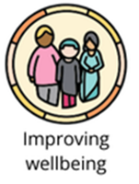 | Improving wellbeing  - Feeling connected to each other, our communities, cultures and spaces around us  - Having opportunities to create meaning in our lives

Foundations of community health and wellbeing
Council plays a pivotal role in laying the foundations for good community health and wellbeing.
There are a broad range of activities Council manages to support community health and wellbeing. Through these combined efforts, Councils fosters environments where community members can thrive physically, mentally, spiritually and socially.
When everything is going well, you don’t even notice it’s happening.

Figure 6: Map of Banyule foundations of health and wellbeing (below)

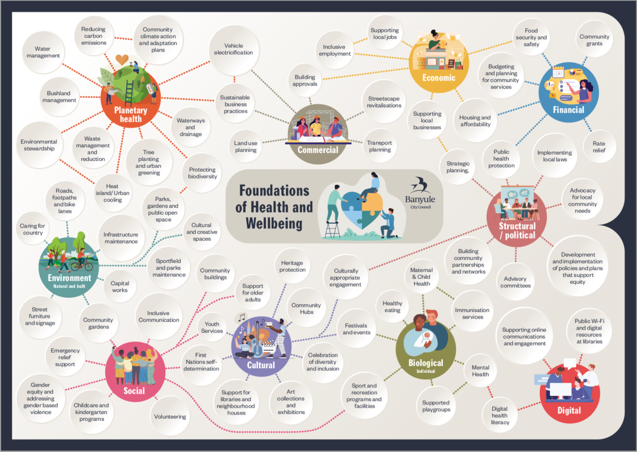

Council’s health and wellbeing services
Council’s role
Banyule Council has a long-standing tradition of delivering services that support the health and wellbeing needs of our community. We offer a variety of programs and activities for people of all ages, backgrounds, and abilities. Additionally, we develop and maintain infrastructure, provide advocacy, data profiles, and funding.
Child and Families
We work with families to promote health and wellbeing and provide a free Maternal and Child Health service for all families with children from birth to school age. We provide first time parent groups and supported playgroups to discuss and share information about parenting and child development, with the opportunity to connect and build positive interactions with others. We offer free vaccinations to help reduce the spread of infectious diseases in our community. Council provides supports for children to attend early education and care programs, including kindergarten buildings and kindergarten central enrolment, so that all children can access free kindergarten programs in the years before they start school.
Youth Services
We value, engage and empower young people between the ages of 12 – 25 years who are living, going to school, working or socialising in the Banyule community. Banyule Youth Services provides activities and opportunities for young people throughout the Banyule community. Our team of Youth Workers offer supports for young people, their families and secondary schools in Banyule. This includes regular programs, events, workshops, school presentations, school holiday activities, and Jets Studios.
Older Adults
We support older adults in Banyule to live and age well. We deliver programs, activities and events to provide social connection, promote positive ageing and improve the health and wellbeing of older adults. We advocate with older adults to address ageism and elder abuse, respect and honour the contributions of older adults and support civic and social participation.
Arts and Culture
We deliver programs that seek to open doors for our diverse communities to participate in and experience engaging and valued creative opportunities. Community festivals that bring people together, exhibitions that share ideas and promote conversation, workshops, activities and performances to stimulate and enrich, public art that tells our stories and brings meaning to spaces. Our team strives to further the richness and depth of Banyule’s creative culture.
Inclusive Employment and Local Jobs
We are committed to creating pathways to employment for people facing barriers to work. Through targeted programs, partnerships, and actions, we support individuals to build skills, gain experience, and secure meaningful employment. Our approach fosters inclusion, diversity, and equity in the workplace, ensuring local jobs benefit the entire community. We collaborate with businesses, community organisations, and other stakeholders to promote economic opportunities and a more inclusive workforce.
Social Enterprise
We champion the growth of social enterprises to drive positive social and economic outcomes within our community. By providing tailored support, networking opportunities, and promotional platforms, we help social enterprises thrive and make a meaningful impact. Our actions encourage innovation, foster sustainable practices, and highlight the unique role of social enterprises in addressing community challenges while creating jobs and opportunities.

Community Engagement
Community engagement refers to the many ways that Council connects with the community during everyday interactions and in the development and delivery of policies, programs, projects and services. High-quality engagement helps Council to make well-informed decisions and achieve effective and transparent governance. Genuine community engagement promotes dialogue, builds understanding and leads to outcomes that are more relevant to the people affected.
Social Policy
Ongoing evaluation of social issues is crucial for guiding the council’s role in supporting the community in areas of risk, harm, disadvantage, and hardship. This includes addressing issues such as gambling, alcohol and drug abuse, homelessness and housing stress, family violence, and gender equity. We work with our community and partners to shape policy, we strengthen partnerships and develop advocacy campaigns to support the diverse and complex needs of our community.
Community amenity management
To support people to lead healthy and safe lives, Council plays a crucial role in maintaining community amenities, including services such as waste management and recovery, cleansing of public spaces, maintaining community assets including footpaths, drains, roads, community building and active transport routes.
Planning sustainable natural environments
We play a crucial role in planning for long term environmental health, governed by legislation such as the Local Government Act 2020, the Climate Change Act 2017 and the Planning and Environment Act 1987. Responsibilities include developing strategies to mitigate and adapt to climate risks, integrating sustainable practices into local planning schemes and policies, improving energy performance, water management, waste avoidance and minimisation and enhancing urban forests and biodiversity.
Planning for sustainable urban growth
We play a pivotal role in planning for sustainable urban growth, including incorporating sustainability and climate resilience into urban growth planning. We develop and implement strategic plans to guide growth of Banyule over decades, with a focus on jobs, housing, transport and liveability. We manage land use and development through the local planning scheme to ensure new developments are sustainable, energy-efficient and environmentally friendly and maintains essential infrastructure such as road, footpaths and community buildings.
Parks, open spaces and sports fields
We have a broad range of responsibilities for providing and managing over 600 hectares of open and green spaces that support community health and wellbeing. We plan and develop new parks and outdoor recreation spaces, maintains and provides for the regular upkeep including landscaping, cleaning and ensuring spaces are safe and accessible. We manage native vegetation, control pests, promote biodiversity and work with community to ensure these spaces meet local needs.
Recreation, sports and leisure
To invite people to be physically active and connected, Council provides recreation, sports and leisure facilities and offers a diverse range of leisure programs which support mental and physical health. Additionally, Council supports various organisation such as sporting clubs, who foster a sense of community.
Community resilience
Council partners with a range of organisations to ensure communities have access to essential material basics including food, health care services, support for older adults and carers, and emergency relief during crises. Our emergency management responsibilities, governed by the Emergency Management Act 2013, involve collaborating with local partners to plan for protection, response, relief, and recovery in relation to public health and environmental emergencies affecting our municipality.
Compliance and public health protection
Council’s Local Laws, Transport and Public Health teams are responsible for public and environmental health protection, traffic safety operations, and local law enforcement, governed by legislation such as the Victorian Food Act 1984, Public Health and Wellbeing Act 2008, Tobacco Act 1987, Road Management Act 2004, Road Safety Rules 2017, and the Environment Protection Act 2017.
Whilst enforcement is a key aspect of Council’s work, significant effort is also dedicated to education and implementing strategies that promote healthy and safe environments, reduce smoking-related harm, and mitigate various public health risks within the municipality. This includes managing infectious diseases by applying the principles of the Public Health and Wellbeing Act 2008, such as minimising spread, taking all reasonable precautions, reducing risk, and ensuring residents have access to information and appropriate treatments.

Leading plans and strategies
Banyule’s Health and Wellbeing priorities were informed by a range of adopted Council plans, strategies and frameworks, and these form the basis for one or multiple of our health and wellbeing priorities.
Marrageil Strategy 2024-2031  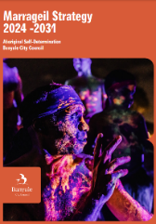 | Social Connection with Purpose  Seeks to lift up the social connection, health and wellbeing of First Nations people through increasing community participation and meaningful and transparent engagement and growing trusted partnerships with shared decision making.  Building Respectful Communities  Seeks to enhance First Nations inclusion and cultural safety ensuring community services and infrastructure is culturally safe, work practices are culturally safe and Woi-wurrung language is valued and amplified.
Active Banyule Plan 2025-2029 | Every Body Active  Outlines Council’s commitments to supporting more people to be more active more often, through focusing on promotion and information, inclusive participation, active infrastructure development and opportunities to uplift standards and performance through partnerships.
Creative Banyule 2023-2031  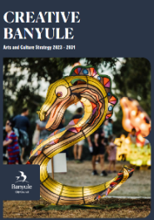 | Building Respectful Communities  seeks to create equitable participation in arts and cultural experiences, with a focus on centring the lived experience of our diverse communities in Council’s arts and cultural programs and unlocking opportunities for people experiencing barriers to inclusion in arts and cultural activities.  Social Connection with Purpose  Through arts, culture and creativity partnerships, Creative Banyule 2023-2031 seeks to enhance social connection and health and wellbeing and celebrate First Nations culture.
Ageing Well in Banyule Framework 2024-2030  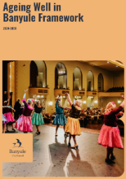 | Building Respectful Communities  Expresses Council’s commitment to ensuring Banyule is an Age Friendly City that supports older adults to live well. It aims to address ageism and honour the wisdom and experience of older adults.  Social Connection with Purpose  Outlines Council’s commitment to ensuring Banyule is an Age Friendly City that supports older adults to live well. It aims to support civic and social participation and connections.
Biodiversity Strategy 2025-2035 | Healthy Planet, Healthy People  Outlines Council’s commitment to protect and enhance our urban biodiversity for our local flora, fauna, First Nations people and all who reside in Banyule, noting that healthy biodiversity underpins a healthy society.
Banyule Bicycle Strategy 2022-2027  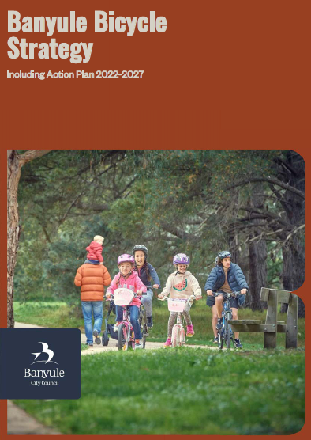 | Every Body Active  acknowledges the important role it plays in supporting and promoting cycling as a safe, healthy and sustainable option for everyone within the community. Encouraging people to be active and take more local trips by bicycle requires behavioural change ‘nudges’ including making it easy, attractive and social. It also requires an ongoing commitment for ongoing promotion and education about cycling opportunities available for the local community.
Child and Youth Framework 2021-2031  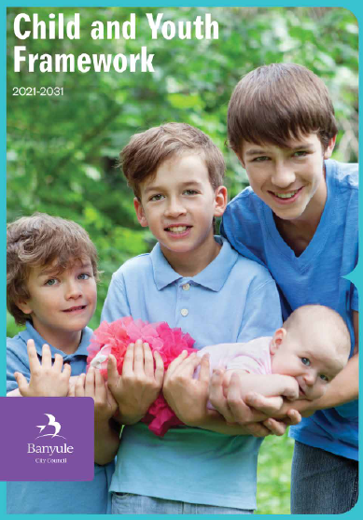 | Lifelong Healthy Habits  This is Council’s commitment to supporting children and young people from pre-birth to 24 years. The Framework recognises that children and young people are experts in their own lives and have valuable insights into what is needed from them to live well in Banyule. It prioritises efforts that create environments that support optimal growth and development, supports and services that foster relationships and connections, and emotional supports that priorities connection to culture, equality and resilience.  Social Connection with Purpose  The Child and Youth Framework 2021-2031 recognises that children and young people are experts in their own lives and have valuable insights into what is needed from them to live well in Banyule. The Framework priorities efforts that create environments that support optimal growth and development, supports and services that foster relationships and connections, and emotional supports that priorities connection to culture, equality and resilience.
Community Climate Action Plan  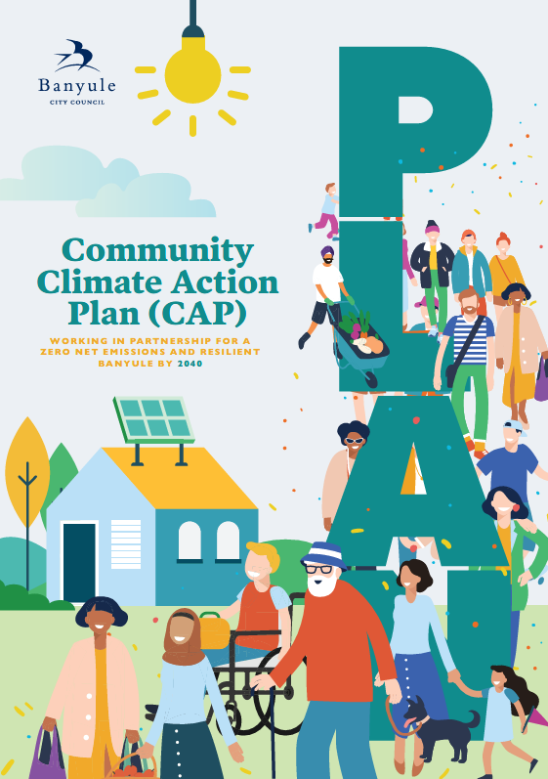 | Healthy Planet, Healthy People  Describes Council’s commitment to supporting community level change to place Banyule on a pathway to zero net emissions by 2040.  Lifelong Healthy Habits  Climate change impacts people’s health, safety, and wellbeing, and our natural environments including wildlife, vegetation and our waterways. The Community Climate Action Plan outlines how Council will support our residents, businesses and organisations to reduce emissions and adapt to the impacts of climate change.
Corporate Emissions Reduction Plan  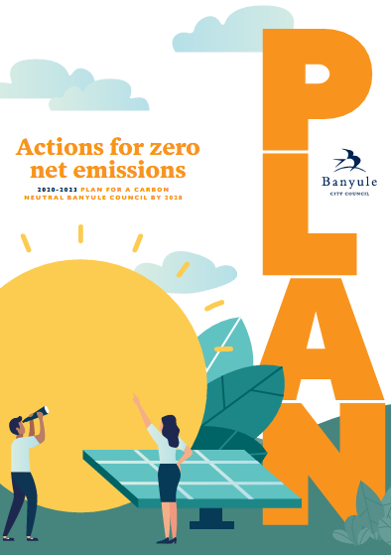 | Healthy Planet, Healthy People  The Corporate Emissions Reduction Plan puts into practice our recognition of the emergency context and a commitment to making a positive difference in Banyule and beyond. It sets out the actions Council staff will take to reduce emissions and mitigate the impact of climate change.
Gambling Harm Prevention Policy 2024-2028  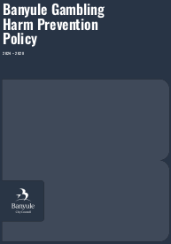 | Lifelong Healthy Habits  This Policy Council to addressing gambling harm through direct interventions, advocacy, planning controls and a focus on community wellbeing.
Public Realm Framework 2024-2034  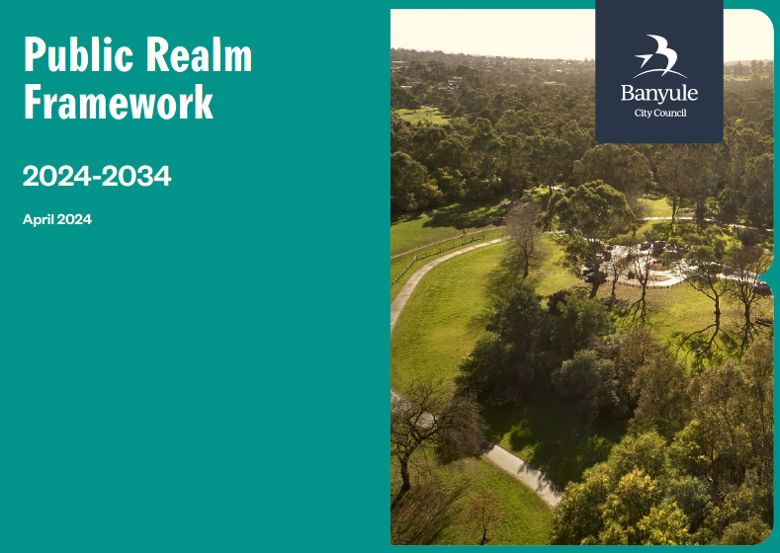 | Every Body Active  The Public Realm Framework 2024-2034 aims to deliver a high-quality baseline for the delivery of public realm that is well-utilised, considered, contemporary and diverse that supports the strategic goals of Council and community.
Resilient and Safe Banyule Framework 2023-2030  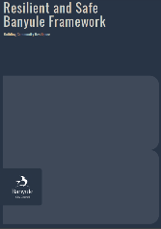 | Healthy Planet, Healthy People  The Framework provides guidance on the natural and built environments are managed and planned in ways that mitigate, respond, and adapt to the impacts of climate change. This includes planning and managing the natural environment in ways that protect and enhance local biodiversity and ensure the health and sustainability of natural resources and assets, including local food systems. It also requires that natural assets and ecosystems are understood, valued and cared for by everyone in the community.  Lifelong Healthy Habits  For people and communities to experience good health and wellbeing, they need access to resources and basic human needs (such as food and shelter), as well as safe, accessible and affordable public health and primary care services, responsive emergency health services and a diverse range of preventative health programs and actions that address the harms arising from local stresses, including racism, discrimination and gambling harm.  Social Connection with Purpose  The Framework provides guidance on how to promote social inclusion and connection. Individuals and communities are provided with a broad range of opportunities to participate in social and cultural programs, activities and events that build social connections and friendships, and increase people’s social support networks. Diversity is accepted, encouraged and celebrated, and all people feel welcome in the community. Opportunities for social inclusion and connection also promote social cohesion and a sense of belonging within the local community more broadly. Social infrastructure and assets, such as libraries, community facilities, parks, playgrounds and open space are also leveraged to facilitate social and cultural connections and participation in community life. To achieve this, they must be affordable, accessible and sustainable, and ensure equitable access for diverse and marginalised communities.
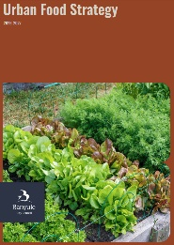  Urban Food Strategy 2023-2027 | Lifelong Healthy Habits  Seeks to inform and guide Council’s strategic planning and decision-making to increase the focus on local food sustainability and food security through the building of community knowledge of and engagement with Banyule’s food system. The Strategy is a key tool for building community resilience and connection in Banyule over the next decade.
Towards Zero Waste Management Plan 2024-2028  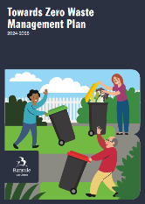 | Healthy Planet, Healthy People  Seeks to challenge and reframe thinking so that community views waste as a resource that can be used in a variety of ways in our existing economy, through engaging community in waste and recycling issues, providing continued support and education to avoid, reduce, reuse and recycle more often. This plan aims to create healthier, more sustainable communities, enhancing the quality of life for all.
Public Open Space Plan 2016-2031  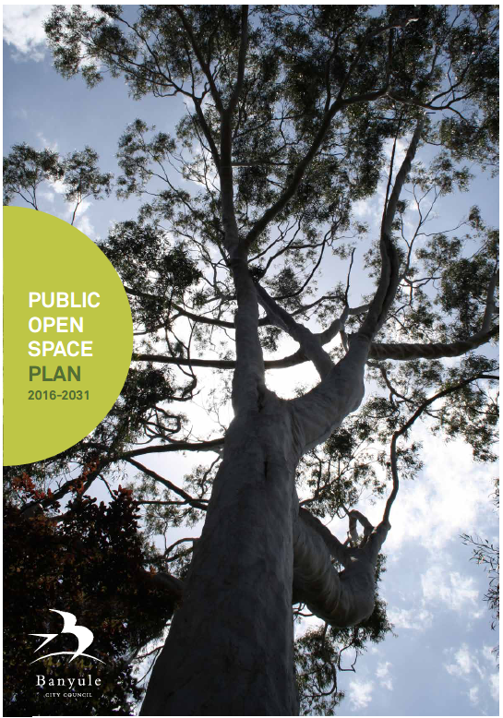 | Every Body Active  Identifies that having access to high quality public open space is critical for community health and wellbeing, noting the benefits of exposure to trees, plant and grass and access to high quality public open space for passive and active recreation. The strategy also recognises the importance of play for physical social and psychological development.
Urban Forest Strategy 2023-2033  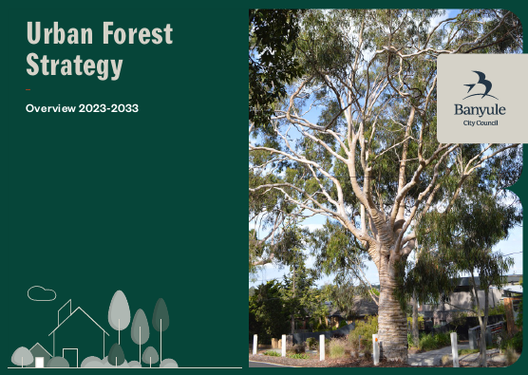 | Healthy Planet, Healthy People  Outlines Council’s commitment to build a healthy urban forest, crucial for the health and wellbeing of the community and the natural environments. The Strategy commits Council to increase canopy cover across the footpath and local road network (45% by 2040 with no loss in suburbs exceeding the target) and canopy cover across the open space shared path network and surrounding playgrounds (50% by 2050).  Every Body Active  The Strategy commits Council to increase canopy cover across the footpath and local road network (45% by 2040 with no loss in suburbs exceeding the target) and canopy cover across the open space shared path network and surrounding playgrounds (50% by 2050).
Walking Strategy 2018-2028  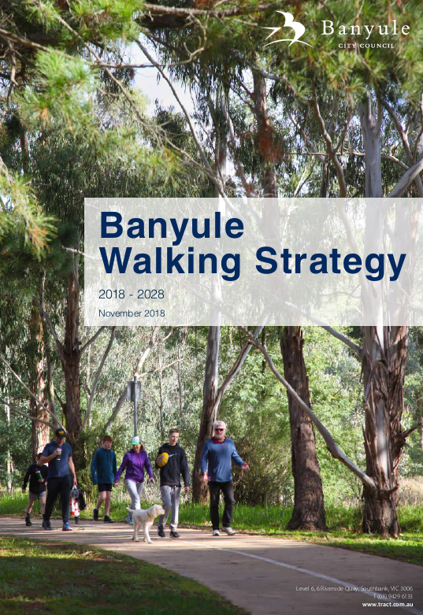 | Every Body Active  The Banyule Walking Strategy 2018-2029 acknowledges the important role Council plays in supporting the development of a walking culture. Getting people active and encouraging more local trips to be undertaken on foot requires both behavioural change and ongoing promotion and education about walking opportunities available for local participation.
Workplace Diversity and Inclusion Strategy 2022-2025 | Building Respectful Communities  The strategy aims to move the dial on the organisational diversity and inclusion maturity, whilst focusing and dedicating attention to structural as well as behavioural inclusion across the organisation.

Key terms
Commercial determinants of health
Activities of the private sector – including strategies and approaches used to promote products and choices – that affect the health of populations.
Gender
The socially learnt roles, behaviours, activities and attributes that any given society considers appropriate for men and women; gender defines masculinity and femininity. Gender expectations vary between cultures and can change over time.
Gender diversity
Gender diversity includes people who identify as agender (having no gender), as bigender (both a woman and a man) or as non-binary (neither woman nor man). Some non-binary people identify as genderqueer or as having shifting or fluid genders. Gender diversity also refers to individuals whose gender expressions differ from what is socially expected and so a gender diverse person may be assigned female and identify as a woman but present their gender in ways that subvert normative notions of femininity.
Gender equality
The equality of rights, opportunities, responsibilities and outcomes between persons of different genders.
Gender equity
Gender equity involves ensuring fair treatment and opportunities for all genders, recognizing that different approaches may be necessary to achieve this fairness.
Gender identity
Gender identity refers to a person's internal sense of their own gender, which may differ from the sex assigned at birth.
Green and blue spaces
Green spaces refer to areas of vegetation, such as parks, gardens, forests, and green corridors, that are accessible to the public, e.g. public parks, community gardens, nature reserves, and urban greenways.
Blue spaces refer to natural or man-made bodies of water and their surrounding environments, which include oceans, rivers, lakes, ponds, wetlands and urban water features like fountains and canals.
Health
A state of complete physical, social and mental well-being, and not merely the absence of disease or infirmity.
Health equity
Health equity is the absence of unfair, avoidable or remediable differences in health status among population groups defined socially, economically, demographically or geographically.
Health literacy
Health literacy represents the personal knowledge and competencies that accumulate through daily activities, social interactions and across generations. Personal knowledge and competencies are mediated by the organizational structures and availability of resources that enable people to access, understand, appraise and use information and services in ways that promote and maintain good health and well-being for themselves and those around them.

Health outcomes
A change in the health status of an individual, group or population that is attributable to a planned intervention or series of interventions, regardless of whether such an intervention was intended to change health status.
Health policy
Health policy refers to decisions, plans, and actions that are undertaken to achieve specific health care goals within a society.
Health promotion
Health promotion is the process of enabling people and populations to increase control over, and to improve their health.
Human rights
Human rights are rights inherent to all human beings, regardless of race, sex, nationality, ethnicity, language, religion, or any other status. Human rights include the right to life and liberty, freedom from slavery and torture, freedom of opinion and expression, the right to work and education, and many more. Everyone is entitled to these rights, without discrimination.
Inclusion
Inclusion occurs when a diversity of people (e.g. of different ages, cultural backgrounds, genders) feel valued and respected, have access to opportunities and resources, and can contribute their perspectives and talents to improve their community.
Intersectionality
Intersectionality refers to the ways in which different aspects of a person’s identity can expose them to overlapping forms of discrimination and marginalisation.
Municipal Public Health and Wellbeing Plan
A Municipal Public Health and Wellbeing Plan (MPHWP) is a strategic document developed by local councils in Victoria, to outline their approach to improving the health and wellbeing of their communities. Under the Public Health and Wellbeing Act 2008, a plan must be prepared every four years. The MPHWP focuses on identifying and addressing local health priorities, promoting healthy lifestyles, and reducing health inequities. It involves collaboration with various stakeholders, including community members, health service providers, and other government agencies, to create supportive environments and implement effective health promotion actions.
Population health
Population health is defined as the health outcomes of a group of individuals, including the distribution of health outcomes within the group. A group or population may be defined by locality, biological criteria such as age and sex, social criteria such as socio-economic status, or cultural criteria. The overall goal of a population health approach is to maintain and improve the health of the entire population and to reduce inequalities in health between population groups.
Primary prevention
Primary prevention aims to prevent disease from occurring by eliminating or reducing the underlying causes, controlling exposure to risk, and promoting factors that are protective of health.
Priority population
Priority populations are groups that experience poorer overall health outcomes, have barriers to accessing adequate healthcare, are economically or socially disadvantaged, and/or have complex care needs or health conditions.

Public health
An organized activity of society to promote, protect, improve, and – when necessary – restore the health of individuals, specified groups, or the entire population. It is a combination of sciences, skills and values that function through collective societal activities and involve programmes, services and institutions aimed at protecting and improving the health of all people.
Secondary prevention
Secondary prevention aims to stop, interrupt, reduce or delay progression of disease through early detection, usually by screening at an asymptomatic stage, and early intervention.
Social determinants of health
The social determinants of health are the social, cultural, political, economic and environmental conditions in which people are born, grow up, live, work and age, and their access to power, decision-making, money and resources that give rise to these conditions of daily life.
Social equity
Social equity refers to fairness, justice, and impartiality in social policy, considering systemic inequalities to ensure everyone in a community has access to the same opportunities and outcomes.
Social justice
Social justice is the belief that everyone deserves equal rights, opportunities, and treatment regardless of their race, economic status, sexuality, or gender identity.
Social prescribing
Social prescribing helps to connect people with mental or physical health problems with non-medical services and activities near them. This can help to improve their physical and mental health.
Tertiary prevention
Tertiary prevention aims to minimise the impact of an established disease and prevent (or delay) complications and subsequent events through treatment, management and rehabilitation.
Wellbeing
Wellbeing is a positive state experienced by individuals and societies. Like health, it is a resource for daily life and is determined by social, economic and environmental conditions.

References
Australian Human Rights Commission 2013, *Fact or fiction? Stereotypes of older Australians*, Australian Human Rights Commission, viewed 13 February 2025, <https://humanrights.gov.au/our-work/age-discrimination/publications/fact-or-fiction-stereotypes-older-australians-2013>
Australian Institute of Health and Welfare 2023, *Australia's health 2023: in brief*, AIHW, viewed 13 February 2025,< https://www.aihw.gov.au/reports/australias-health/australias-health-2023-in-brief>
Banyule City Council, 2019. *Banyule Municipal-Wide Emissions Reduction Plan: Final Report*, viewed 13 February 2025, https://hdp-au-prod-app-ban-shapingbanyule-files.s3.ap-southeast-2.amazonaws.com/8715/7645/1204/3930._Banyule_Municipal-Wide_Emissions_Reduction_Plan_Final_report.pdf
Banyule City Council 2022, *Household Survey Overview Report*, Banyule City Council, viewed 13 February 2025. <Banyule Household Survey 2022 - Overview Report.PDF>
Banyule City Council 2024, *Gambling Harm Prevention Policy 2024-2028*, Banyule City Council, viewed 13 February 2025, <https://shaping.banyule.vic.gov.au/gambling>
Community Views. (2023). *Living in Banyule, 2023* - Views Report. https://320463.fs1.hubspotusercontent-na1.net/hubfs/320463/Community%20Views/Living%20in%20Banyule%2c%202023%20-%20Views%20Report.pdf >
Meis-Harris, J., Saeri, A., Boulet, M., Borg, K., Faulkner, N., & Jorgensen, B. *Victorians Value Nature – Survey Results*. Melbourne, Australia: BehaviourWorks Australia, Monash University, March, 2019, viewed 13 February 2025, https://www.ari.vic.gov.au/research/people-and-nature/victorians-value-nature/victorians-value-nature-survey
Peucker, M., Vaughan, F., Doley, J., and Clark, T. (2024), *Understanding reporting barriers and support needs for those experiencing racism in Victoria*. Research report. Victoria University: Melbourne, viewed 13 February 2025, < Understanding reporting barriers and support needs for those experiencing racism in Victoria>
Sustainability Victoria (2023). *State of Sustainability Report*, viewed 13 February 2025, https://assets.sustainability.vic.gov.au/susvic/Document-SV-State-of-Sustainability-Report.pdf
Victorian Government 1984, *Food Act 1984*, Victorian Government, Melbourne, viewed 13 February 2025, https://www.health.vic.gov.au/food-safety/the-food-act-1984
Victorian Government 2004, *Road Management Act 2004*, Victorian Government, Melbourne, viewed 13 February 2025, <https://www.legislation.vic.gov.au/in-force/acts/road-management-act-2004/066>
Victorian Government 2006, *Charter of Human Rights and Responsibilities Act 2006*, Victorian Government, Melbourne, viewed 13 February 2025, <https://www.legislation.vic.gov.au/in-force/acts/charter-human-rights-and-responsibilities-act-2006/015>Multicultural Victoria Act 2011
Victorian Government 2017, *Climate Change Act 2017*, Victorian Government, Melbourne, viewed 13 February 2025, https://www.climatechange.vic.gov.au/legislation/climate-change-act-2017
Victorian Government 2017, *Environment Protection Act 2017*, Victorian Government, Melbourne, viewed 13 February 2025, <https://www.legislation.vic.gov.au/in-force/acts/environment-protection-act-2017/005>
Victorian Government 2020, *Gender Equality Act 2020*, Victorian Government, Melbourne, viewed 13 February 2025, <https://www.legislation.vic.gov.au/in-force/acts/gender-equality-act-2020/004>
Victorian Government 2020, *Local Government Act 2020*, Victorian Government, Melbourne, viewed 13 February 2025, <https://content.legislation.vic.gov.au/sites/default/files/2020-04/20-9aa003%20authorised_0.pdf>
Victorian Government 2023, *Victorian Public Health and Wellbeing Plan 2023–27*, Victorian Government, Melbourne, viewed 13 February 2025, https://www.health.vic.gov.au/victorian-public-health-and-wellbeing-plan-2023-27
Victorian Government 2024, * Child Wellbeing and Safety Act 2005*, Victorian Government, Melbourne, viewed 13 February 2025, https://content.legislation.vic.gov.au/sites/default/files/2024-06/05-83aa044-authorised.pdf
Victorian Government 2024, *Disability Act 2006*, Victorian Government, Melbourne, viewed 13 February 2025, https://content.legislation.vic.gov.au/sites/default/files/2024-07/06-23aa050-authorised.pdf
Victorian Government 2024, * Racial and Religious Tolerance Act 2001*, Victorian Government, Melbourne, viewed 13 February 2025, <https://content.legislation.vic.gov.au/sites/default/files/3b0e389a-7fec-36a3-b4fe-f2f33595ec0c_01-47aa011%20authorised.pdf>Banyule Community Vision 2041
Victorian Government 2024, * Tobacco Act 1987*, Victorian Government, Melbourne, viewed 13 February 2025, <https://content.legislation.vic.gov.au/sites/default/files/2024-06/87-81aa100-authorised.pdf>
Victorian Government 2023, *Victorian Population Health Survey*, Victorian Government, Melbourne, viewed 13 February 2025, <https://www.health.vic.gov.au/population-health-systems/victorian-population-health-survey>
United Nations 2015, *Sustainable Development Goals*, United Nations, New York, viewed 13 February 2025, <https://sdgs.un.org/goals>

