My day at Beale Family Day
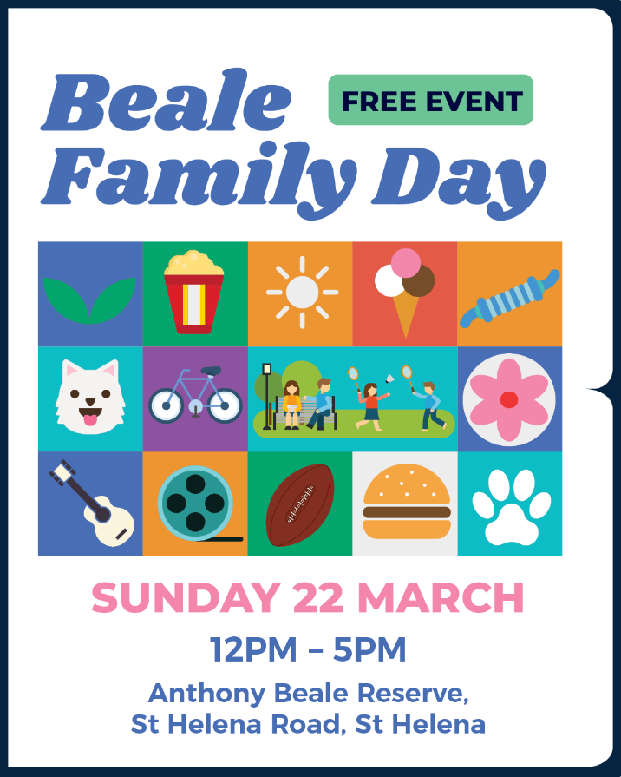
This book belongs to

______________________________________________________________________________________________________________

I am going to Beale Family Day.
It’s at Anthony Beale Reserve in St Helena. The event will be behind St Katherines Church.
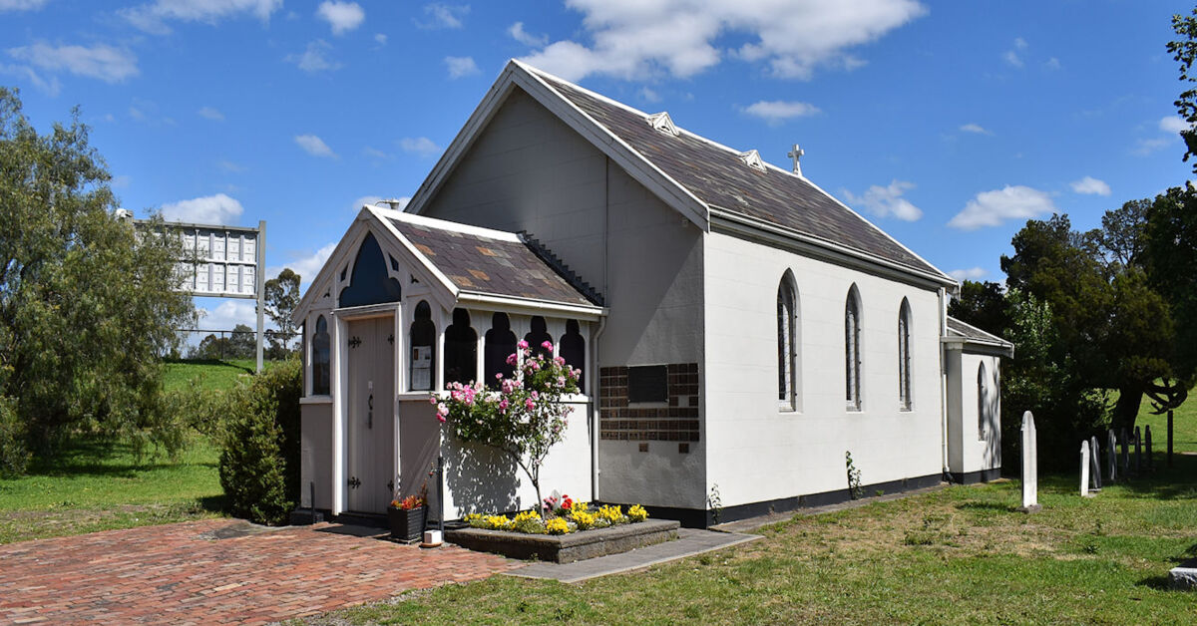

At Beale Family Day, lots of people come together to learn,
look, and play at the stalls and activities.

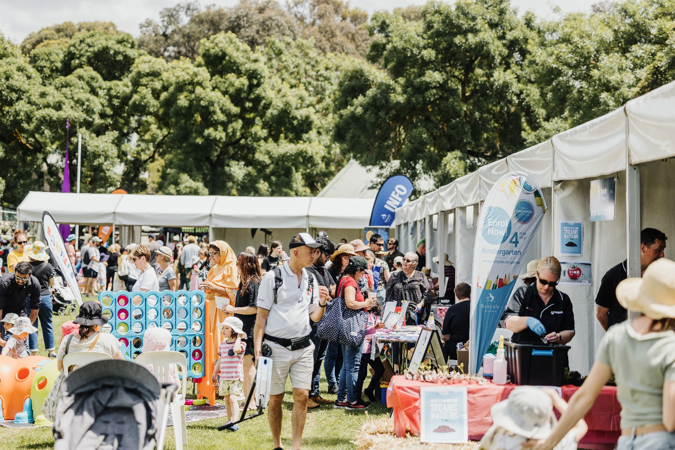

There will be music, craft activities, things to make and do.

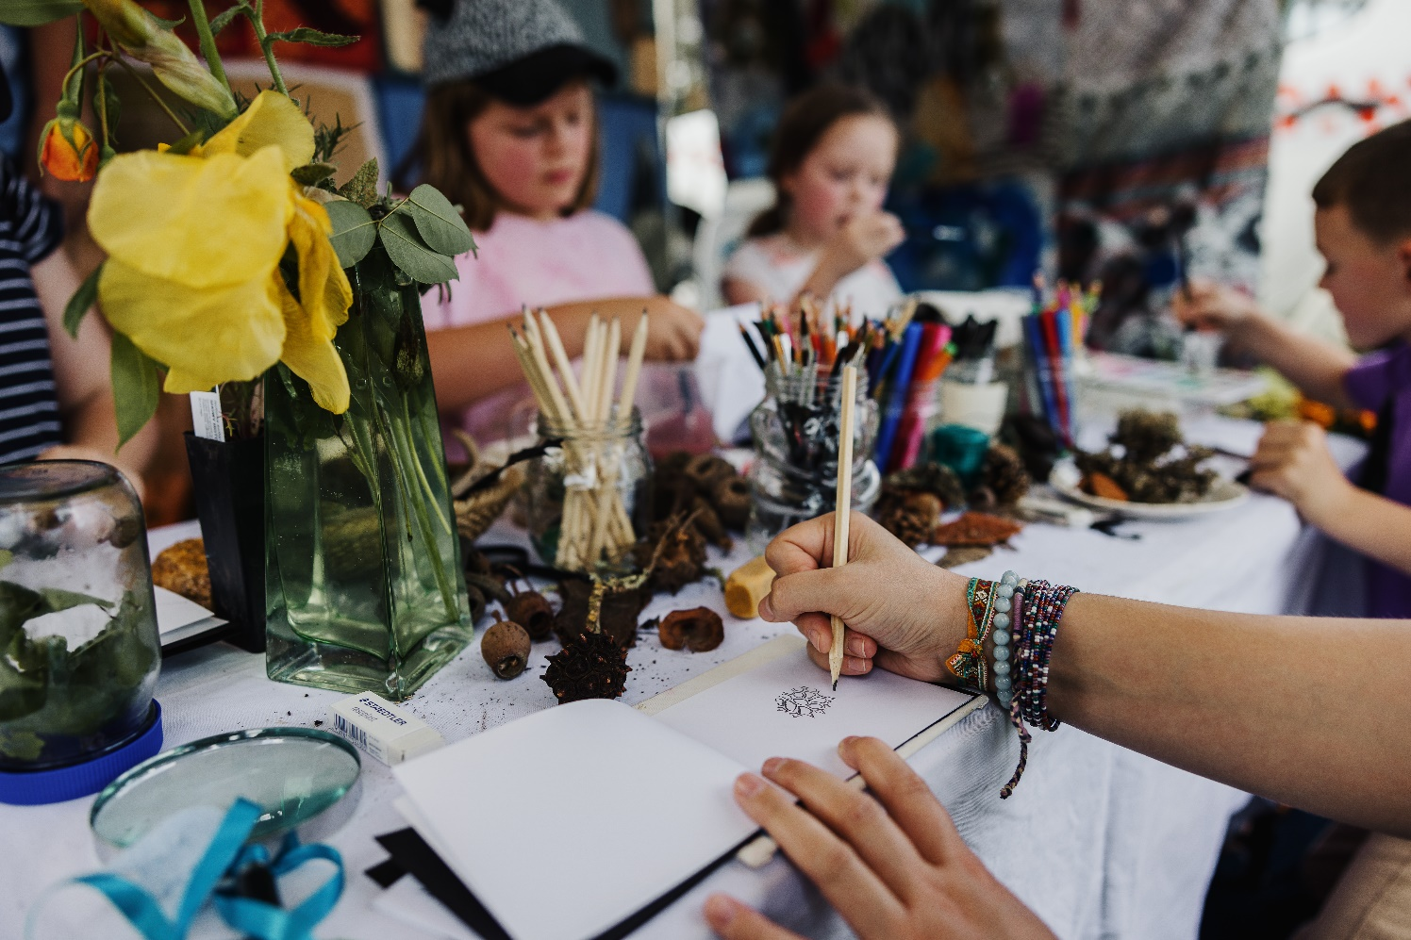

There will be dogs allowed on their leads.
I can also get a funny photo with my pet.


After the activities finish,
I can also stay to watch a movie in the park.



If I feel like I need to sit and rest in a quiet space,
I can go to the Chillout Space and relax.
There are also headphones available for me to use, if the noise and people get too loud.

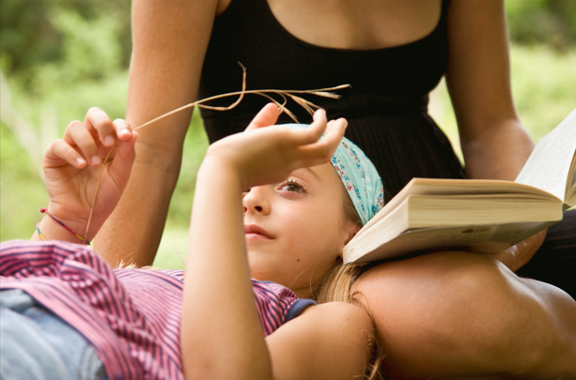

There will be a lot of people at the festival.
I need to stay close to my family / carer.
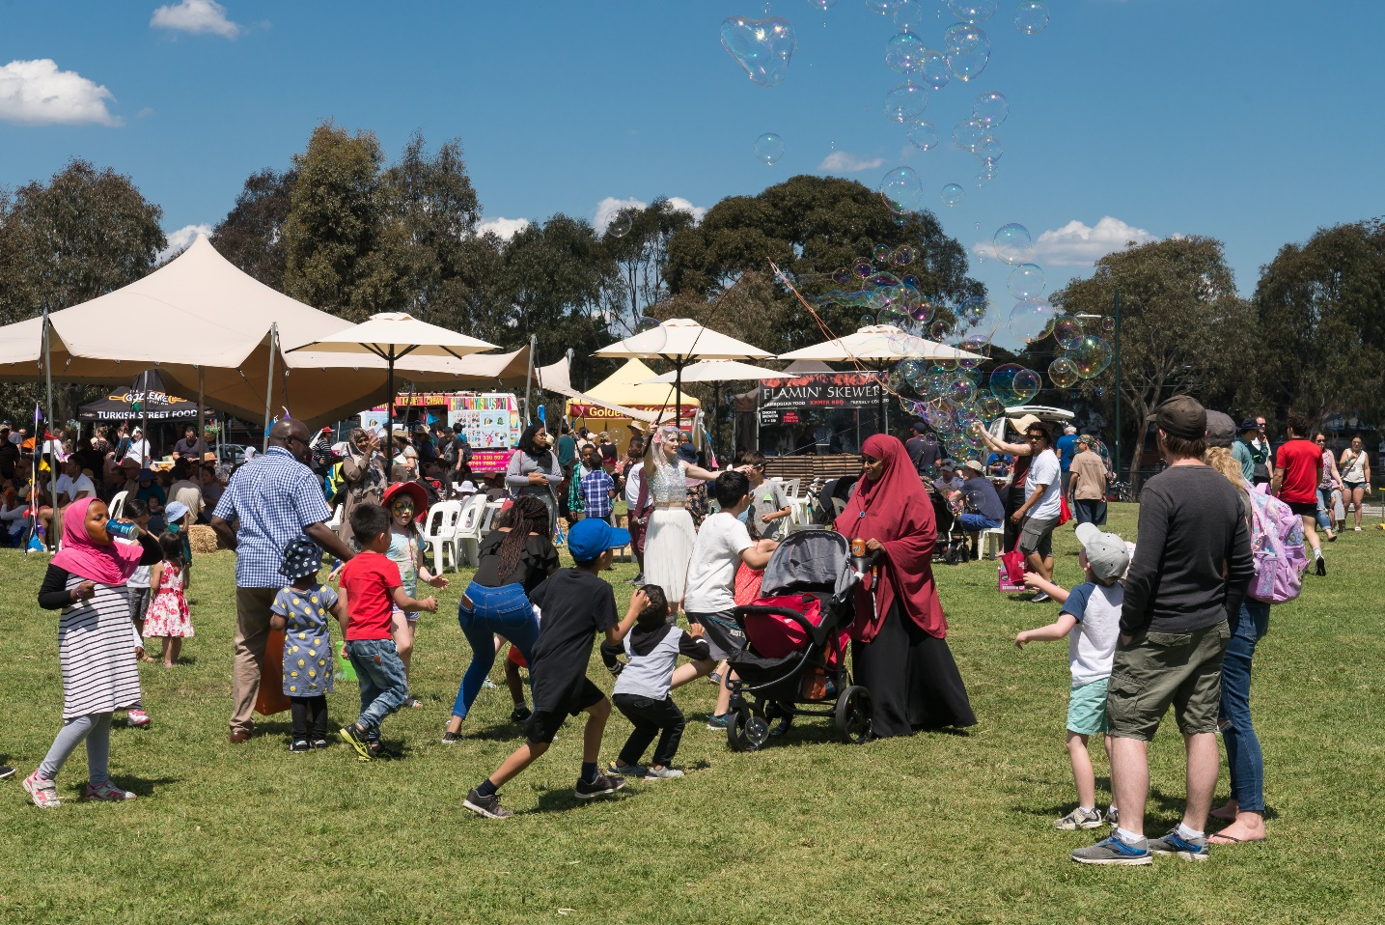

If I am allowed, I can get food and drinks
from a food and drink stall.


If I need help, there are friendly event staff walking around at the event.
They will be wearing a bright orange or yellow vest.


Going to Beale Family Day will be fun!
