My day at Harmony Bazaar
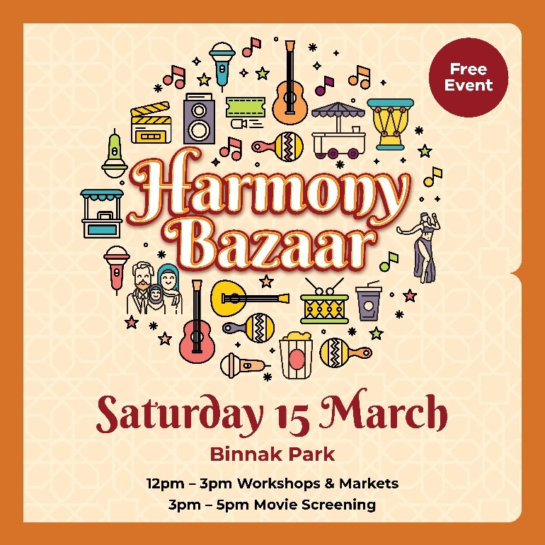
This book belongs to

______________________________________________________________________________________________________________

I am going to Harmony Bazaar. It’s at Binnak Park in Watsonia North.

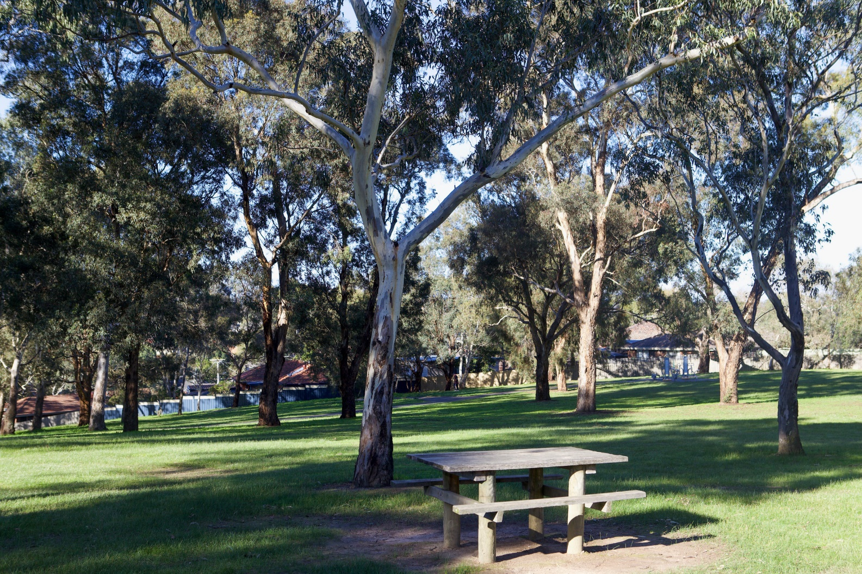

At Harmony Bazaar, lots of people come together to learn,
look, and play at the market stalls and activities.

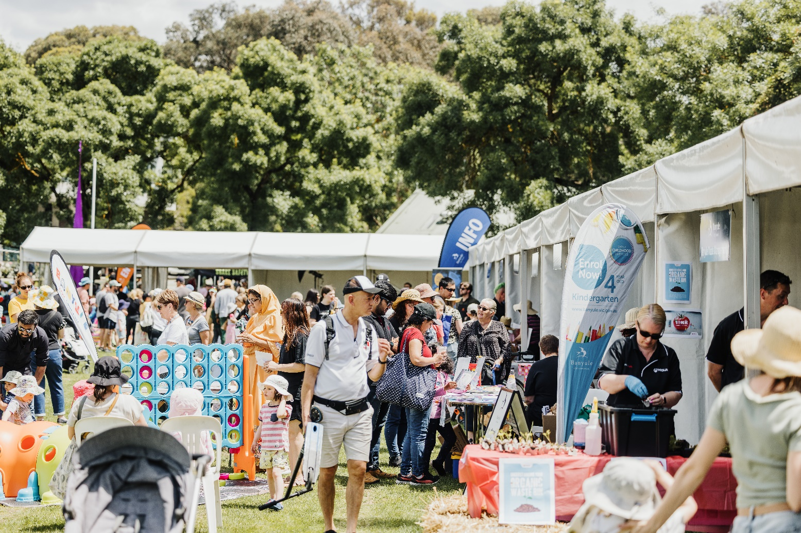

There will be dance and singing workshops that I can join in on.
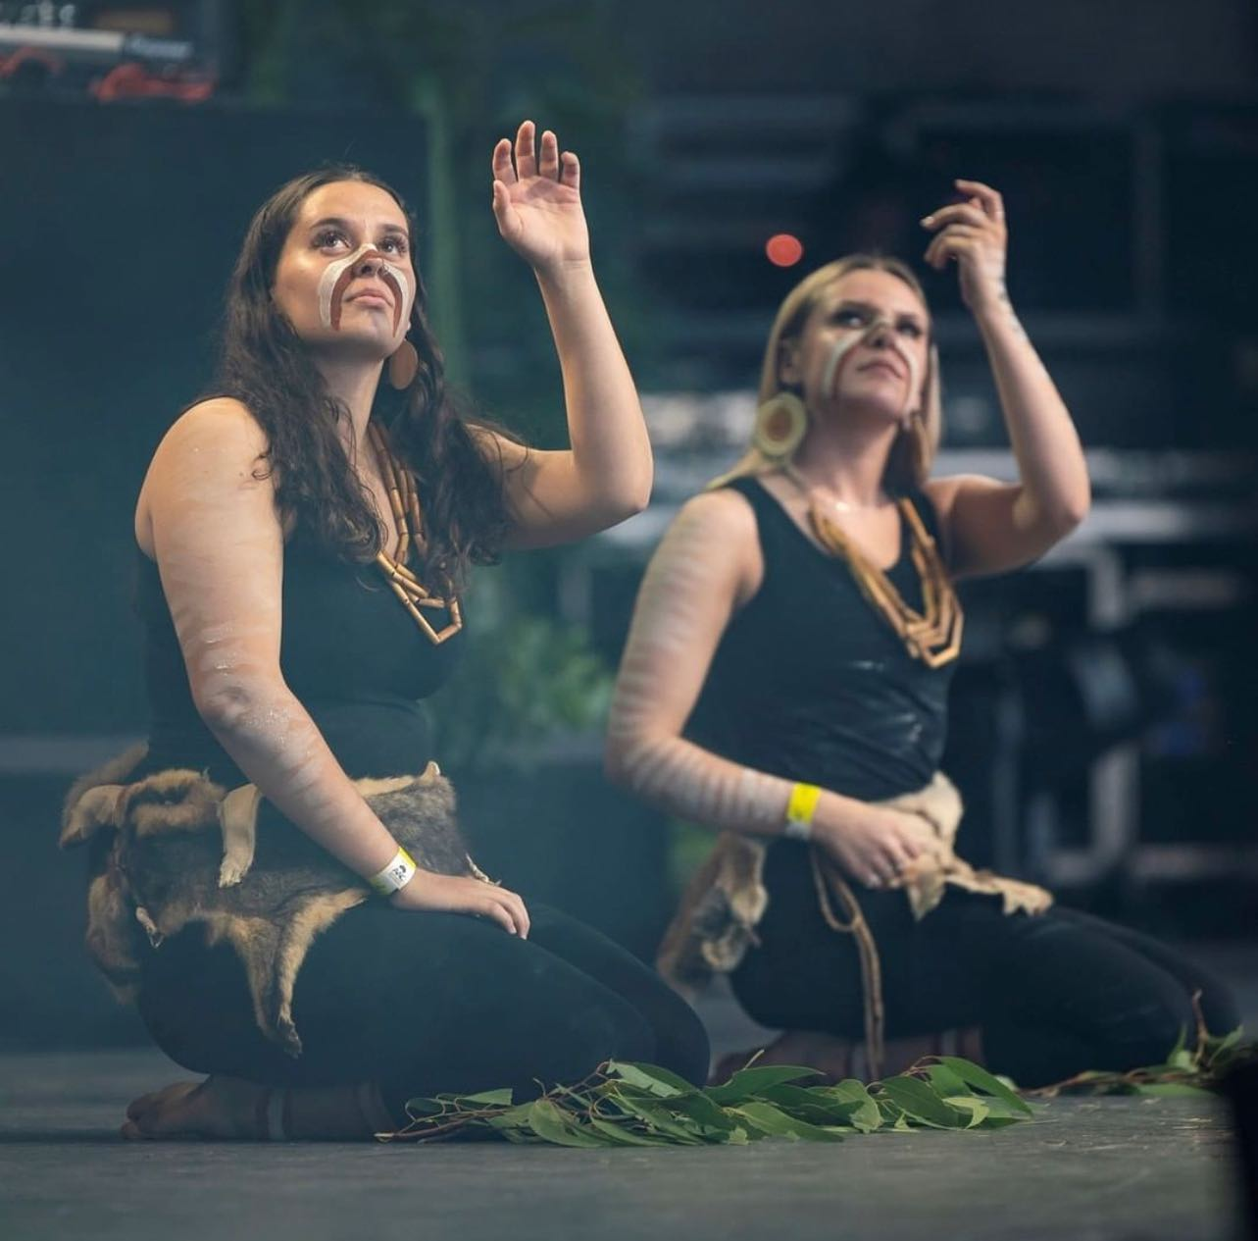

There will also craft activities, things to make and do.

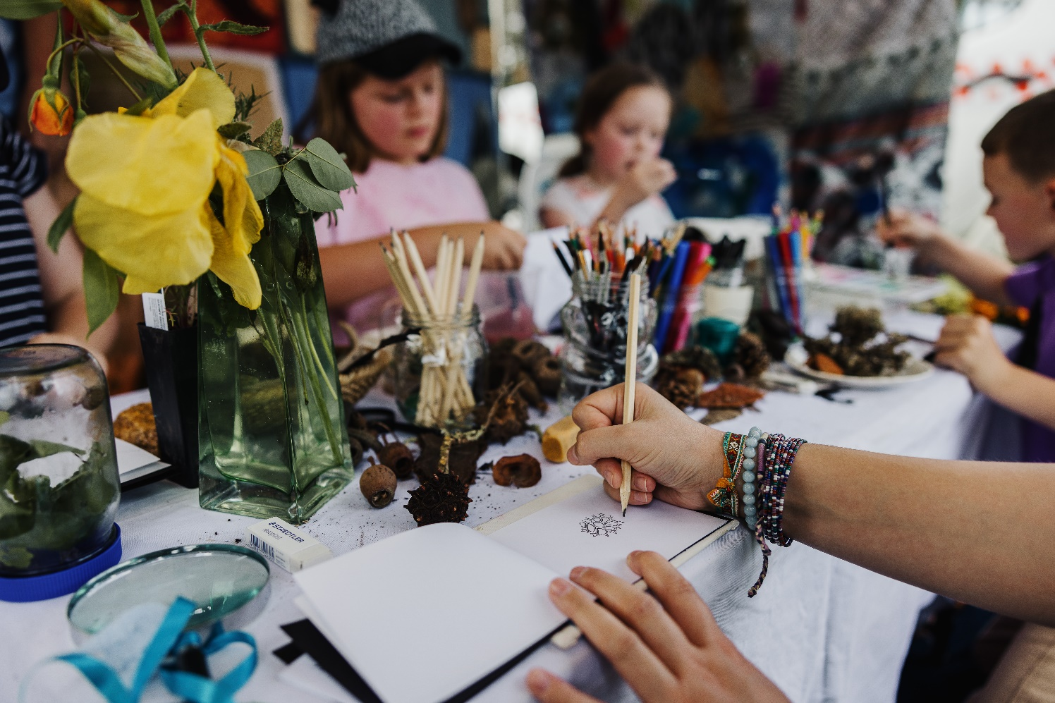

I can also get Henna done, if my carer says its ok.

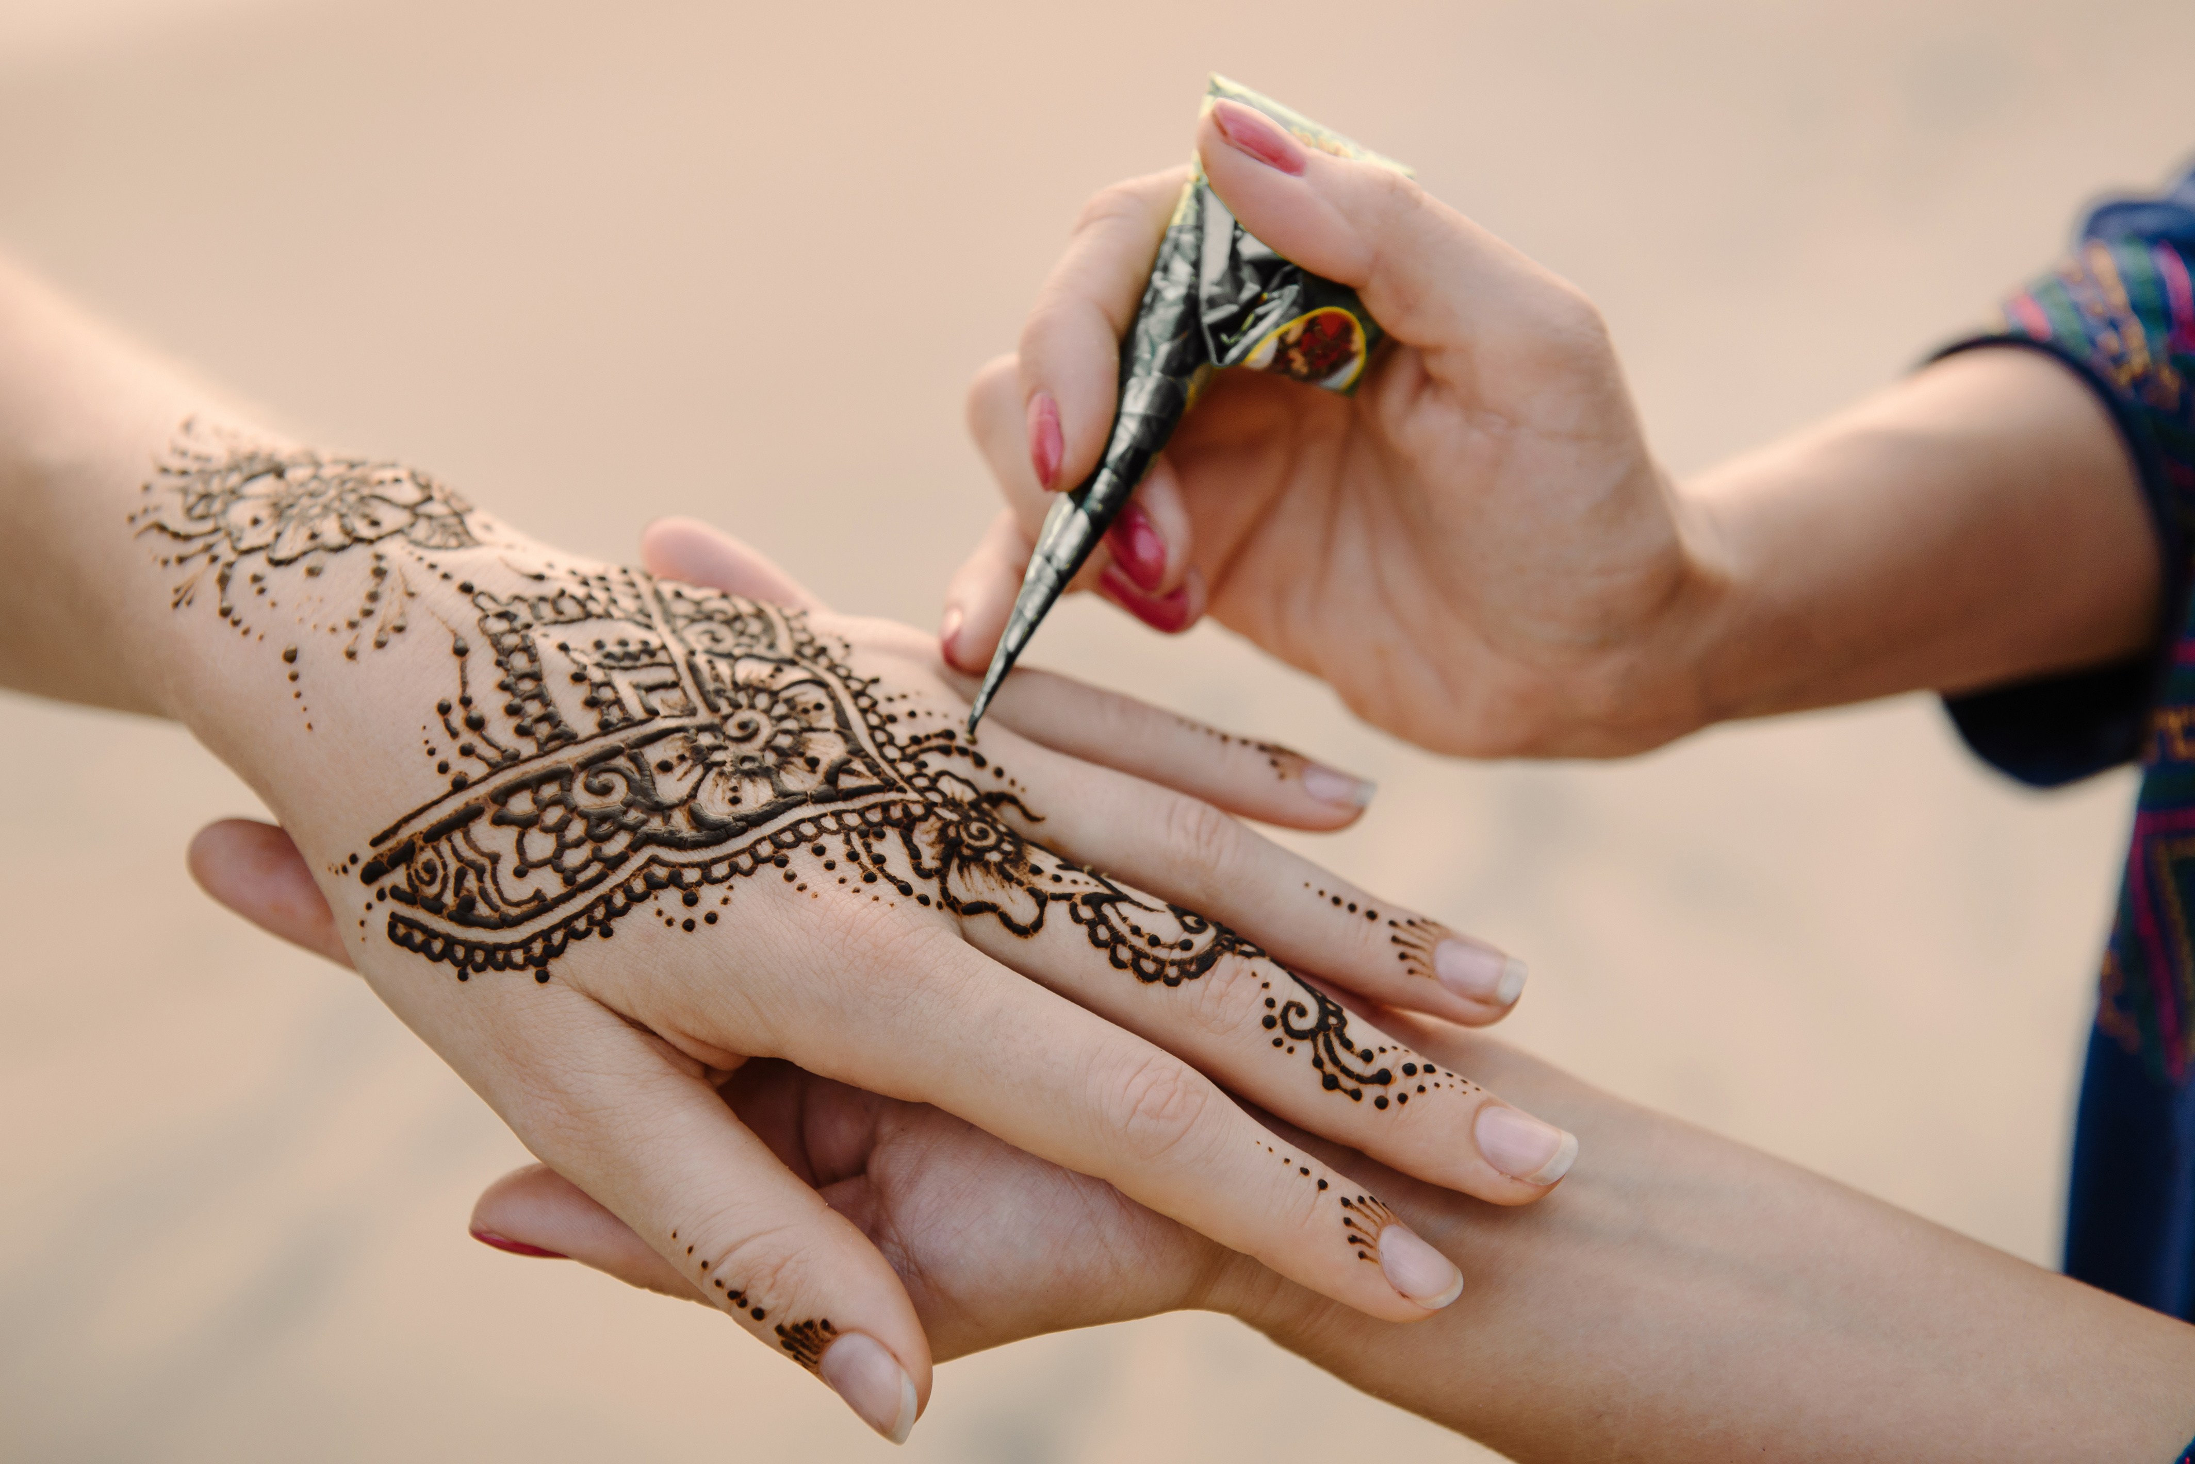

After the markets and music workshops finish,
I can also stay to watch a movie in the park!



If I feel like I need to sit and rest in a quiet space,
I can go to the Chillout Space and relax.
There are also headphones available for me to use, if the noise and people get too loud.



There will be a lot of people at the festival.
I need to stay close to my family / carer.
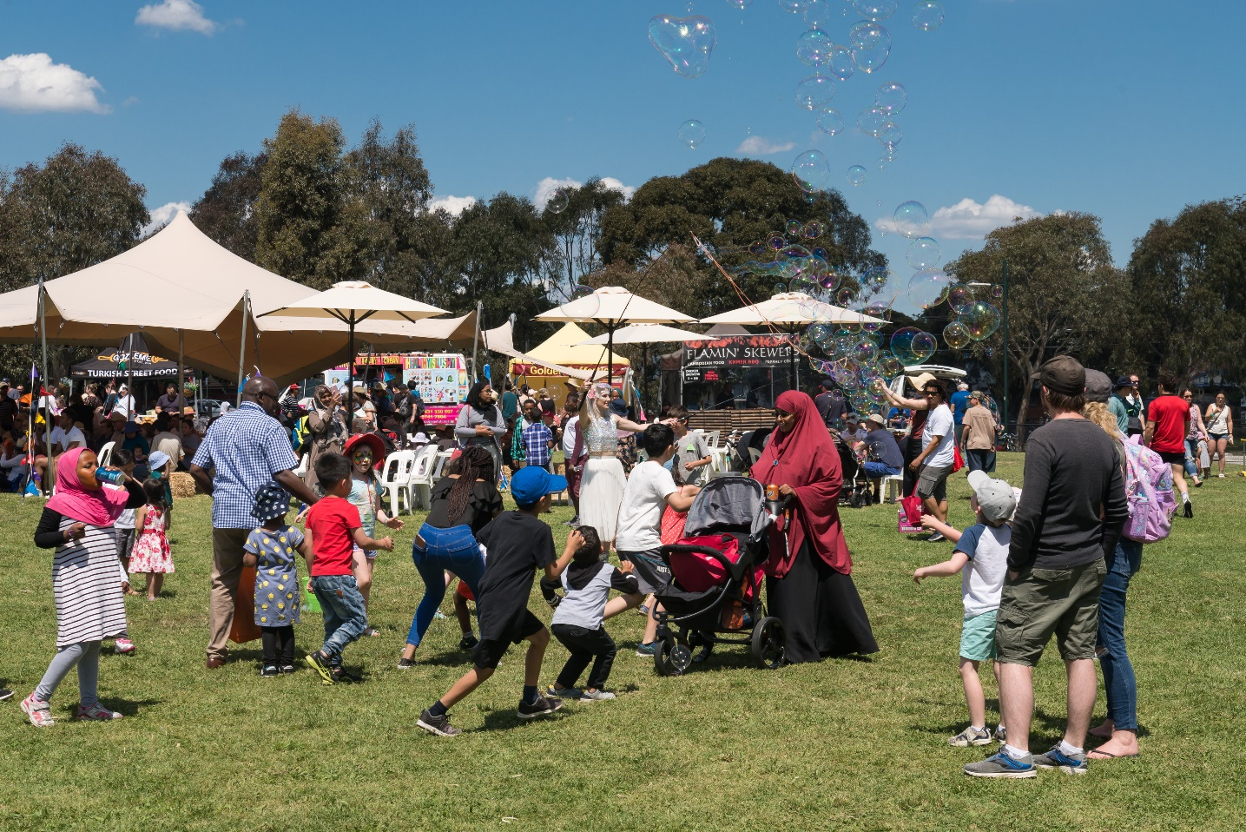

If I need to go to the toilet, I will let my family/carer know
and they will help me to follow the map.
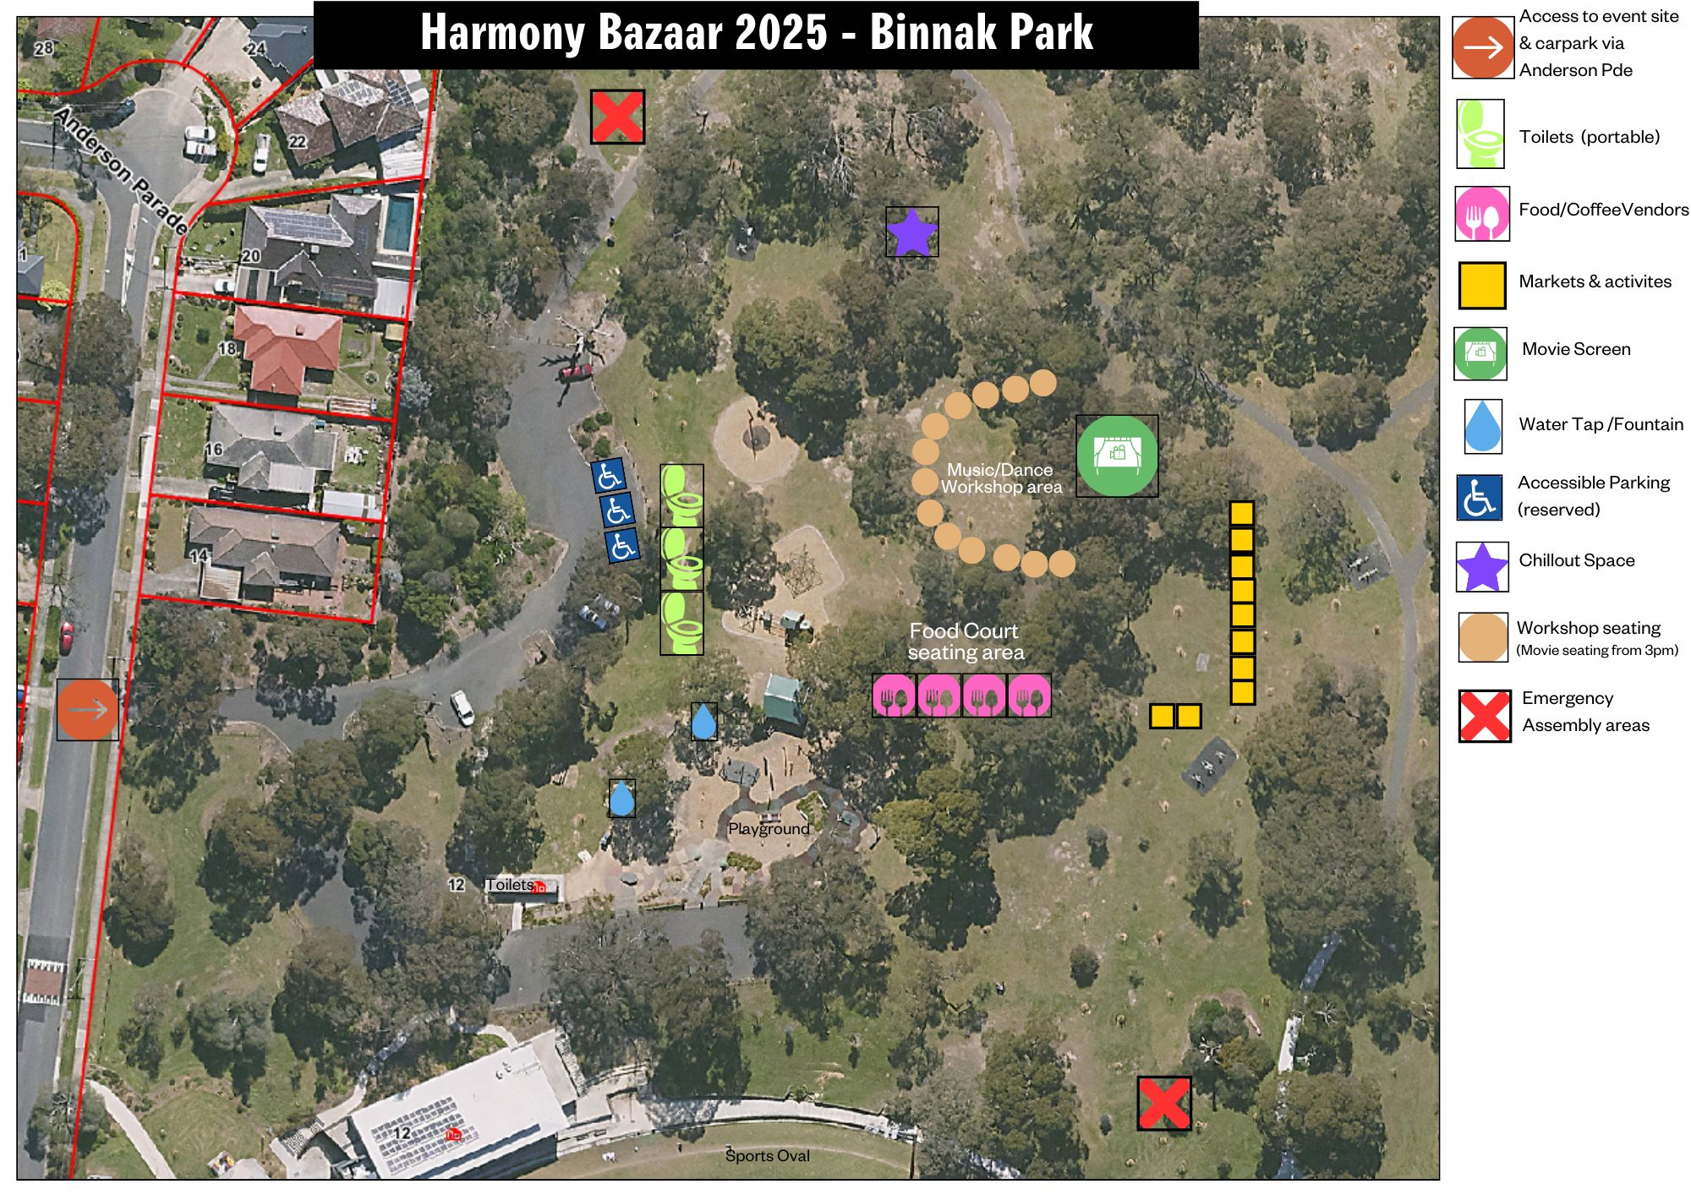
If I am allowed, I can get food and drinks at Harmony Bazaar
from a food and drink stall.
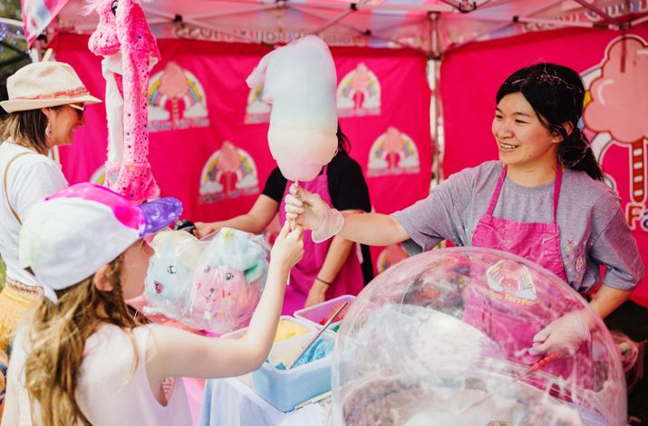

If I need help, there are friendly event staff walking around at the event.
They will be wearing a bright orange/yellow vest.
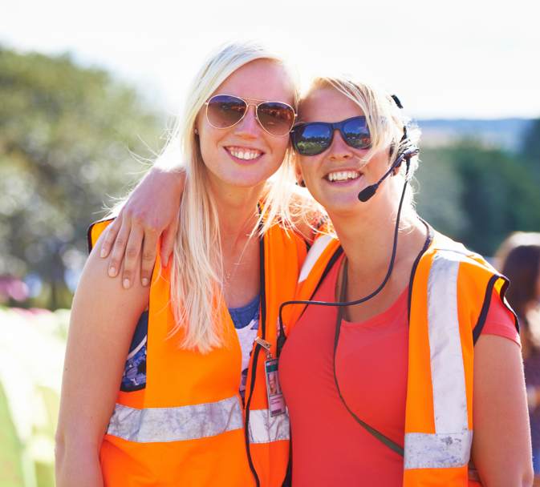

Going to Harmony Bazaar will be fun!

