
The Banyule Plan
2025–2029

The Banyule Delivery Plan 2025–2029

Contents
Acknowledgement of the Traditional Custodians 2
The Banyule Delivery Plan 2025–2029 3
What is the Banyule Plan? 3
Council’s key initiatives 4
What is a Health and Wellbeing Plan? 6
Priority theme 1 Our Inclusive, Healthy and Connected Community 7
Priority theme 2 Our Sustainable Environment 14
Priority theme 3 Our Well-Built City 18
Priority theme 4 Our Valued Community Assets and Facilities 23
Priority theme 5 Our Thriving Local Economy 26
Priority theme 6 Our Trusted and Responsive Leadership 29
Appendix A – Accessible long description of Banyule’s Health and Wellbeing Plan priorities infographic 37
Contacting Banyule City Council 38

Acknowledgement of the Traditional Custodians
Banyule City Council is proud to acknowledge the Wurundjeri Woi-wurrung people as Traditional Custodians of the land and we pay respect to all Aboriginal and Torres Strait Islander Elders, past, present and emerging, who have resided in the area and have been an integral part of the region's history.
Diversity statement
Our community is made up of diverse cultures, beliefs, abilities, bodies, sexualities, ages and genders. We are committed to access, equity, participation and rights for everyone: principles which empower, foster harmony and increase the wellbeing of an inclusive community.

The Banyule Delivery Plan 2025–2029

Purpose of this document
The Banyule Plan 2025–2029 (the Banyule Plan) was adopted by Council on 23 June 2025, after extensive community engagement. This included online and precinct-based engagement, ending with four deliberative community sessions. Council also consulted advisory committees, held planning sessions, and conducted workshops with councillors and staff.
The Banyule Plan is reviewed every four years to ensure it meets the community’s changing needs and priorities. It is implemented through a four-year delivery plan, which outlines the initiatives and services funded by the annual budget each year.
The Banyule Plan and the four-year Banyule Delivery Plan 2025–2029 (The Banyule Delivery Plan) detail the key initiatives and services Council will provide to address community needs and priorities. These plans aim to help achieve the goals set out under the priority themes in the Community Vision 2041 (the Community Vision).
The Banyule Delivery Plan responds directly to the Community Vision’s priority themes and is based on various considerations, including:
- Banyule’s health and wellbeing priorities for 2025–29 and climate action response.
- Commitments in the long-term Capital Works program and Council’s initiatives program.
- Commitments in key strategic documents, strategic plans and policies adopted by Council (including key plans and policies under review or development).
- Actions aligned with and funded through the budgeting process.
- Activities continuing from the previous Council Plan 2021–2025 Annual Action Plan 2024–2025.
- Our response to feedback received through ongoing community engagement.

What is the Banyule Plan?
The Banyule Plan is Council’s main strategic document, outlining priorities and focus areas for the next four years. This plan is guided by and includes Banyule’s Community Vision and shows how Council will work in partnership with the community, agencies and other key stakeholders to achieve the Community Vision. It helps focus on what really matters and measure our successes.
At Banyule City Council the Health and Wellbeing Plan is integrated into the Banyule Plan, creating one clear document. This plan focuses on both the location and infrastructure within the municipality, as well as the people who live, work or visit here.

Read the full Banyule Plan.

Council’s key initiatives

Since being elected in November 2024, the Mayor and councillors have been combining what we have heard from our targeted consultation programs and ongoing feedback from our community together with key programs, projects and initiatives that are already underway to help develop a clear road map for the future.
With ongoing economic and societal challenges facing our community along with state and federal elections, it is essential that Council work in partnership with other levels of government, community members and organisations and the private sector to make a positive impact on people that live, work, visit and do business in Banyule.
Council has identified the following key initiatives that we will focus on delivering over the next four years.

Financial sustainability
With inflation and cost of living pressures impacting everyone, our focus is on sound financial management that supports us to deliver value for money services and projects, while paying down debt and returning the overall budget to surplus. We are focus on doing this while continuing to take the pressure of those doing it tough through hardship and support arrangements.

Environmental action
We’ve got bold plans to increase our overall tree canopy to 30%, to protect and enhance our biodiversity and reach zero emissions by 2028. We will continue to develop projects and programs that get us to these targets while also supporting the community to work towards a sustainable and green future that protects and improves the green spaces that we all know and love.

Local business support
We’ll continue to work alongside and in partnership with our small business community and broader business sector to create a thriving economic environment and opportunities for business to grow sustainably and succeed.

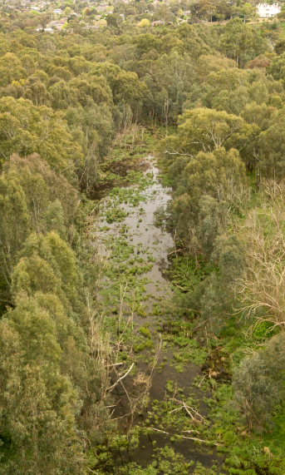

Advocating for community needs
We remain committed to advocating on behalf of our community including:
- Securing funding to deliver a major upgrade at Ivanhoe Aquatic and a West Heidelberg Integrated Services Hub to meet the growing needs for community services, food relief and support
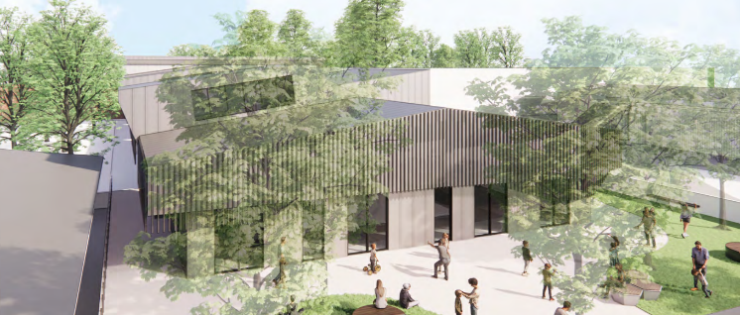
Figure 1 | Design concept for Ivanhoe Aquatic
- Minimising the impact on residents during the North East Link (NEL) construction and working with the State Government to get good project outcomes and an upgrade to the Watsonia Train Station in line with the NEL project construction
- Better transport connections with improved walking, cycling and public transport within Banyule and beyond.

Improved community assets and projects
Each year our capital works program continues to upkeep our roads, footpaths and drains as well as delivering important community assets and projects that improve community safety, amenity and the appeal of local places.

Health and wellbeing
We will focus on improving access to healthy food, improving mental health, addressing family violence and creating opportunities for people to be active, included and connected.
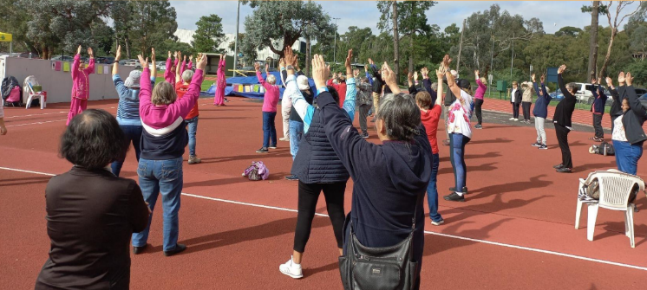

Housing and homelessness
Too many people are still struggling to have a roof over their heads, and we’ve seen an increase in people experiencing homelessness, along with a gap in critical services for those needing help. We will continue to work with government and other partners to find ways to increase housing in the right areas and offer support for those that need it most.
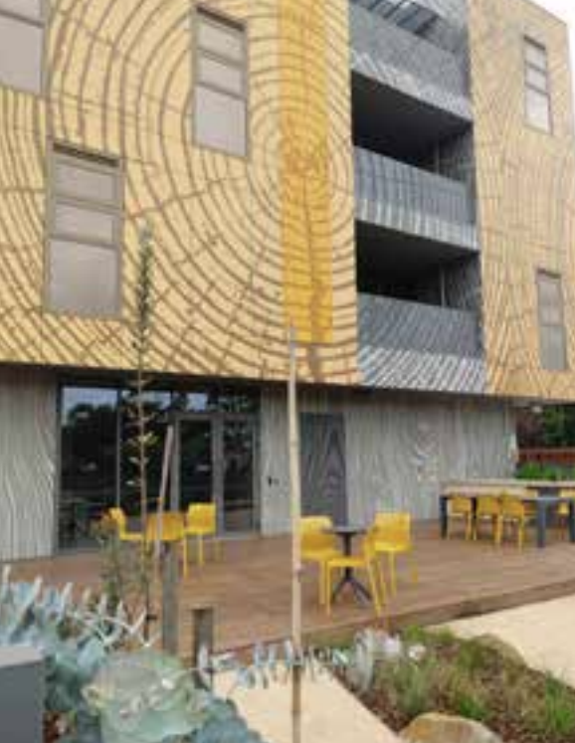
Figure 2 | Affordable housing in Bellfield

How initiatives get delivered
The Banyule Delivery Plan and our ongoing service delivery play a critical role in how these key initiatives will be addressed. Through the actions and strategies of Council, you will see practical and specific examples of these initiatives being brought to life. Each year as part of our community reporting we will demonstrate what has been and is being done to make an impact on these key initiatives.

What is a Health and Wellbeing Plan?
In accordance with the Public Health and Wellbeing Act 2008, all local councils in Victoria must address the health and wellbeing needs of their communities through a Health and Wellbeing Plan. This strategic plan outlines the Council’s primary goals and priorities for safeguarding, enhancing and promoting public health and wellbeing within the municipality. Additionally, councils are committed to meeting health and wellbeing planning requirements under the Gender Equality Act 2020 and the Climate Change Act 2017.
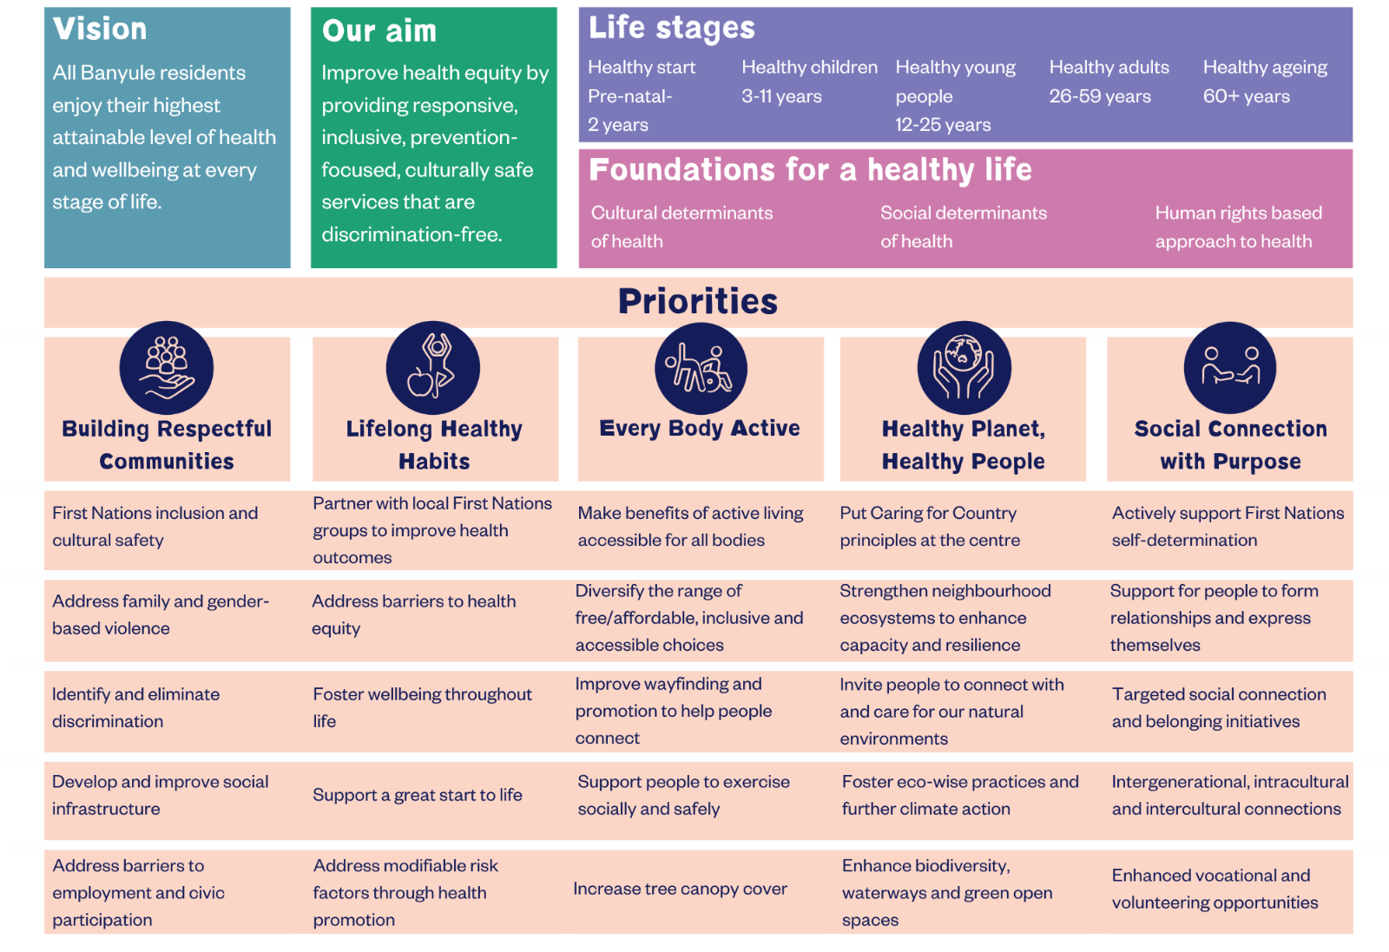
Figure 1 | Banyule's Health and Wellbeing Plan priorities
For an accessible long description of this infographic, see Appendix A.

Health and Wellbeing Plan priorities icon legend used throughout the document

Building Respectful Communities
Lifelong
Healthy Habits
Every Body
Active
Healthy Planet, Healthy People
Social Connection with Purpose

Read the full Banyule Plan, which includes the Health and Wellbeing Plan.


Priority theme 1
Our Inclusive, Healthy and Connected Community

A vibrant, connected, active and safe community where diversity and inclusion are valued and encouraged.

Our shared vision for the future
By 2041, Banyule remains a diverse, inclusive and vibrant community, where everyone feels at home.
- We honour and learn from Aboriginal and Torres Strait Islander cultures and support self-determination.
- Community spaces and services are welcoming and accessible to all, with no barriers to inclusion or participation.
- Banyule is safe and people enjoy nutritious food, lead active lifestyles and experience their best health and wellbeing.
- Our festivals and events are inclusive and reflect our diversity.
- We protect and celebrate our arts and cultural history, offering opportunities for people to connect, participate and be represented.
- Volunteering, education and work encourage and build community connection.
- Valuing people’s differences underpins our sense of belonging.
- We recognise the importance of good mental health and emotional wellbeing.

What we will do to achieve our goals
Table 1 | Priority theme 1 – Our Inclusive, Healthy and Connected Community – Banyule Delivery Plan actions
No. | Banyule Delivery Plan action | Desired community outcomes | How will Council achieve the outcomes | Partners | Council team delivering this action
1. | Strengthen the partnership with the Barrbunin Beek Aboriginal Gathering Place | Lift up the social connection, health and wellbeing of First Nations people.  Actively supporting First Nations self-determination is a municipal health and wellbeing objective. | - Develop a Memorandum of Understanding (MOU) and a partnership agreement with Barrbunin Beek by 30 June 2026.  - Hold two strategic meetings with Barrbunin Beek each year by  30 June 2026. | - Barrbunin Beek  - First Peoples' Assembly of Victoria  - Victorian Government | First Nations  
2. | Build awareness of, and address barriers posed by ageism, discrimination, racism and ableism across the community | Respectful communities ensure that everyone, regardless of their background, feels valued and included.  Respectful interactions build trust and cooperation among community members, leading to stronger, more resilient communities. | - Deliver the annual building respectful communities action plan which addresses:  - First Nations inclusion and cultural safety  - Building awareness and eliminate of all forms of discrimination  - Prevention of family and gender-based violence  - Equitable, safe and inclusive community infrastructure. | - Women’s Health in the North | Community Impact  
3. | Increase diverse community participation in festivals, exhibitions, arts grants, programs and events | People build social connections with purpose, as a health and wellbeing priority, which increases people’s sense of value, belonging and wellbeing. | - Deliver major events and festivals including Malahang, Twilight Sounds, Carols by Candlelight and other community events.  - Support 14 community-led exhibitions at Ivanhoe Library and Cultural Hub that support local creatives by  30 June 2026. | - Local artists  - Cultural and identity-based groups | Arts and Culture  
4. | Develop and implement an exhibition program of national cultural significance to elevate the Ivanhoe Library and Cultural Hub's profile as a premier arts venue | Increased visibility of creativity, culture and heritage, fosters a positive sense of place. | - Curate high-quality exhibitions and public programs at Ivanhoe Library and Cultural Hub that attract state-wide audiences and media attention. | - Australian artists  - National Gallery of Australia | Arts and Culture
5. | Partner with local community organisations to drive collaborative actions that improve social connection across neighbourhoods, with a focus on 3081 postcode | Decrease in social isolation and increase in community’s ability to withstand challenges.  Better connection between service providers to share themes and informs improved services and supports for the community. | - Funding agreements are aligned with community needs and health priorities.  - Connecting community and service provider networks to address emerging community needs.  - Increase community services at Shop 48 – The Harmony Centre to support local community organisations. | - Community partners  - Service providers  - Victorian Government | Community Partnerships
6. | Continue to develop works programs and opportunities in collaboration with the Wurundjeri Narrap team to learn shared practices | Strengthen relationships and work in respectful partnership with the Traditional Custodians of Banyule, the Wurundjeri people, identified Elders and other Aboriginal and Torres Strait Islanders. | - Environmental programs developed and delivered. | - Traditional Custodians of Banyule  - Wurundjeri people  - Identified Elders  - Aboriginal and Torres Strait Islanders | Bushland Management  Environmental Operations  
7. | Implement the Urban Forest Strategy actions | Enhanced community engagement with the Urban Forest through nature strips and private realm trees. | - Actions are reported on as per the Implementation Plan for the Urban Forest Strategy primarily in the State of Environment report. | - Community  - Local native nurseries  - Utility owners | Urban Forestry  
8. | Deliver the Youth Spaces Plan | Open spaces will attract more young people, through creating spaces specifically for them. This will encourage a greater diversity of users who benefit from open spaces. | - Design and deliver young people spaces at:  - Greensborough War Memorial Park  - Aminya Reserve.  - Design young people spaces for:  - Ivanhoe Park  - Poulter Reserve. | - Community  - Schools  - Youth/young people | Open Space Planning and Design  Youth and Community Connections
9. | Building resilience and capacity across the community to prepare for and manage acute and chronic stressors | Community is supported to have the knowledge and tools to manage crisis events. | - Annual action plans delivered to support the approach outlined in the framework by 30 June 2029. | - Emergency services  - Municipal Emergency Management Plan Committee  - Neighbourhood houses | Emergency Management
10. | Implement the Support Service and Information Navigation Program | Residents feel supported to navigate and find appropriate support services that can help them to manage daily living activities, participate in activities that they enjoy and remain connected to community. | - Launch and promote the program.  - Monitor and evaluate utilisation annually, identifying gaps and advocate to address availability, access and affordability of local services. | - Community organisations | Youth and Community Connections
11. | Implement the Active Banyule Plan to support community participation in active living opportunities, with a focus on sports and recreation | Promotes a healthy and happier community by providing opportunities for active participation in sport and recreation.  More people are more active, more often across diverse community settings. | - Increase physical activity levels by at least 5% by 2030.  - Deliver an online physical activity directory.  - Club strength data indicates annual growth in sporting participation among traditionally underrepresented cohorts such as First Nations, Cultural and Linguistically Diverse (CALD), women and girls, LGBTIQA+, people with disability and socio-economically disadvantaged. | - Sports clubs  - Community groups  - Residents  - Leisure centres  - Victorian Government | Sport, Recreation and Community Infrastructure  Banyule Leisure

Council teams and the services they provide
Here’s how different Council teams are helping deliver this priority theme through the services they provide.

First Nations
- Developing Aboriginal and Torres Strait Islander programs
- Embedding of the previous Reconciliation Action Plan
- Developing the new Aboriginal Self-Determination Strategy and Action Plan
- Leading community relationships and support particularly regarding Traditional Custodians and community Elders
- Managing the First Nations Traineeship Program.

Aged Services
- Organising social support groups
- Providing social support services for individuals including assistance with accessing the community shops, carer support, delivered meals, property maintenance and modifications, assessment and outreach
- Providing the Home and Community Care Program (HACC PYP) through assessment, community support, meals and property maintenance for younger people under 65 who do not qualify, are awaiting National Disability Insurance Scheme (NDIS).
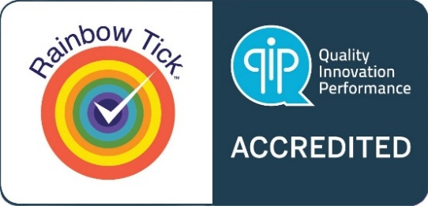

Arts and Culture
- Developing community culture and heritage
- Managing art collections, art exhibitions and public art installations
- Producing cultural programs, events and festivals for the community.

Banyule Leisure
- Managing and operating Council’s owned and operated leisure and aquatic centres which include Ivanhoe Aquatic Centre, Olympic Leisure Banyule and NETS Stadium
- Increasing community participation in aquatic, health and fitness services and programs
- Increasing community participation in structured and unstructured sports.

Civic Precincts and Major Facilities
- Overseeing, managing and activating civic precincts including Ivanhoe Library and Cultural Hub, Greensborough Civic Precinct, The Centre Ivanhoe and future oversight of the Rosanna Library Precinct
- Managing key contracts and partnerships for the above facilities
- Managing community halls and rotundas for hire.

Community Impact
- Providing organisational leadership in collective impact, social policy work, and community inclusion to the organisation
- Developing and delivering Council’s Inclusive Banyule Plan
- Providing education and raising awareness to support inclusion for diverse communities, including First Nations people, LGBTIQA+ communities, multicultural groups and people with disabilities
- Building strong relationships to achieve the Community Vision and the Banyule Plan
- Supporting Council’s population and advisory committees and health and wellbeing planning.

Community Partnerships
- Managing Shop 48 The Harmony Centre and Bellfield Community Hub and working with the 3081 Outcomes Framework to ensure both facilities are meeting community needs
- Developing and monitoring funding agreements for community service organisations that receive annual Council funding
- Maintaining the Banyule and Neighbourhood Houses Partnership Agreement and facilitating the action plan.

Early Childhood Services
- Operating two kindergartens and three long day care centres
- Facilitating the Banyule Kindergarten Central Enrolment Scheme which manages registrations for the 27 kindergartens
- Providing support and information, activities and programs for children and their families
- Facilitating the development of integrated and coordinated services for children and their families
- Managing early childhood facilities and capital works program.

Emergency Management
- Managing community safety and resilience, and emergency management programs including preparedness, response, relief and recovery
- Developing fully integrated strategic and operational plans, to respond to incidents affecting the community and to promote and maintain high standards of public health and wellbeing, community resilience and emergency preparedness across Banyule.

Environmental Health
- Promoting a healthy environment for all community members
- Protecting the community and environment from waste and pollution
- Preventing communicable diseases to achieve healthy outcomes
- Promoting industry best practice for food, health, accommodation and tobacco businesses.

Maternal and Child Health and Immunisation Services
- Delivering maternal and child health services including key ages and stages
- Providing parent education to first time parents
- Delivering supported playgroup to vulnerable families in accordance with Department of Families, Fairness and Housing funding.

Service Reform
- Providing strategic support for the review of reforms, programs and services within the Family and Community Services business unit and broader Community Wellbeing directorate, including Continuous Improvement and Strategic Projects teams.

Sports and Leisure Contracts
- Managing contracts and master planning of major leisure and recreation facilities which include Ivanhoe Golf Course, Chelsworth Park, WaterMarc, Macleod Recreation Centre and Watsonia Pool.

Sports, Recreation and Community Infrastructure
- Planning sport and recreation services and community infrastructure
- Increasing sport participation opportunities
- Seasonal allocation of sports pavilions and grounds
- Managing leases and licences for sporting clubs.

Youth and Community Connections
- Supporting individuals, LGBTIQA+ communities and culturally and linguistically diverse (CALD) residents
- Delivering the Rainbow Space program, which offers a safe and inclusive space where LGBTIQA+ young people can make friends, build emotional intelligence and take part in creative skill-building activities
- Providing inclusive support for LGBTIQA+ young people through Banyule Youth Services by sharing up-to-date information via an online directory and printed brochures at schools and community centres
- Hosting Youth Summits that include workshops for young people and teachers and offering resources such as a sport inclusion guide and an online teacher toolkit to support LGBTIQA+ inclusion, equity and belonging
- Facilitating the development and delivery of integrated and coordinated services for young people and their families
- Providing young people communications
- Facilitating community connectedness and responding to identified needs through the delivery of programs for the community
- Providing regional assessment service, service access and navigation
- Providing age-friendly programs, events, activities, social planning and support
- Community development and strengthening.


Priority theme 2
Our Sustainable Environment

A progressive and innovative leader in protecting, enhancing and increasing the health and diversity of our natural environment,
where we all commit to playing an active role in achieving environmental sustainability and reducing waste and carbon emissions.

Our shared vision for the future
By 2041, Banyule is a leader in environmental sustainability and recognised as one of the most sustainable communities.
- Aboriginal culture and Caring for Country principles guide our sustainability efforts.
- Council partners with the community, education and private sectors, investing in solutions to tackle climate change.
- Population growth aligns with sustainability goals, ensuring equal access to natural spaces.
- We are empowered, adaptive, proactive and resilient to climate change.
- Council promotes sustainable transport options and is on the way to being carbon negative, with a circular economy achieving zero waste.
- We are well-informed on waste, food security and climate actions, and Council leads environmental education.
- We protect and strengthen biodiversity to reduce species extinction and enhance wildlife corridors and urban vegetation, including managing pets and pests.
- Urban farming and home-grown food practices are supported and encouraged to be the norm.
- Trees, green spaces and the Urban Forest are abundant and maintained to enhance liveability and neighbourhood character.
- Environmentally sustainable design is central to planning and development, and the use of renewable energy in our homes, businesses and facilities is normal.

What we will do to achieve our goals
Table 2 | Priority theme 2 – Our Sustainable Environment – Banyule Delivery Plan actions
No. | Banyule Delivery Plan action | Desired community outcomes | How will Council achieve the outcomes | Partners | Council team delivering this action
1. | Strengthen partnership with the Wurundjeri Woi-wurrung Narrap team | Put Caring for Country principles at the centre. | - Implement two strategic meetings per year by  30 June 2026.  - Host one per year learnings and education session per year. | - Wurundjeri Woi-wurrung Corporation | First Nations  Bushland Management
2. | Enhance the natural environment through environmental restoration in partnership with the community and other stakeholders | Benefits to open space amenity, wildlife habitat, urban forest canopy and shade and ecological connectivity.  Connecting community to nature. | - Plant 250,000 indigenous plants across public and private spaces by 2035.  - Reach 110,000 plants by 2029. | - Local residents  - Victorian Government  - ‘Friends of’ groups  - Environmental groups  - Volunteers  - Other LGAs | Environment
3. | Develop and implement a Climate Change Adaptation Plan and Monitoring, Evaluation, Reporting and Improvement process (MERI) | Provide guidance to Council on its approach to managing climate risk and supporting the community to adapt and be resilient. | - In-depth staff and community co-design sessions.  - Plan developed by 31 March 2026.  - Commence plan following adoption.  - Monitor and improve continuously. | - Council staff  - Local residents  - Community groups  - Victorian Government  - Community service providers | Environment
4. | Electrify all remaining Council facilities by replacing gas infrastructure with electric alternatives | Electrify all facilities by 2028–29.  Achieve improved air quality and thermal comfort for facility users. | - Undertake the WaterMarc/  1 Flintoff Street electrification project.  - Electrify remaining small facilities. | - Tenants and facility users  - Australian Government  - Local residents | Capital Works  Environment
5. | Replace Council’s existing fleet with zero emissions vehicles to achieve Council’s net zero emissions target | Reduce Council’s fuel emissions.  Improve air quality.  Support Council’s net zero emissions target. | - Replace all existing fleet with zero emissions vehicles. | - Climate Emergency Australia  - Northern Alliance for Greenhouse Action  - Industry bodies | Fleet Management  Environment
6. | Deliver the Irrigation Renewal Program – Sportsfields for Banyule | Irrigation renewal will address poor, inefficient, near or at end-of-life systems that no longer operate to current day standards or requirements. | - Complete one sportsfield irrigation renewal per year, within allocated budget. Renewal projects delivered to standards, on time and within budget. | - Sporting clubs  - Yarra Valley Water  - Local suppliers  - Local contractors | Sportsfields and Parks Assets  Capital Works
7. | Develop and implement environmental sustainability initiatives across aquatic and leisure facilities to support Councils carbon emissions reductions | Support Council’s net zero emissions target. | - Priorities and initiatives identified for each site.  - External funding partners identified to assist with funding.  - WaterMarc Pool blankets – Undertake review and efficiencies and energy reductions. | - Community  - Victorian Government  - Australian Government  - Contract partners  - Patrons | Sports and Leisure Contracts

Council teams and the services they provide
Here’s how different Council teams are helping deliver this priority theme through the services they provide.

Bushland Management
- Managing environmental reserves
- Restoring habitat
- Recording flora and fauna
- Controlling noxious weeds and pest animals.

Environment
- Developing and implementing policies and strategies that set Council’s strategic direction for environmental sustainability, including the Corporate Emissions Reduction Plan, Community Climate Action Plan and Biodiversity Strategy
- Supporting sustainability upgrades into Council buildings and public spaces to conserve energy and lower greenhouse gas emissions
- Building the capacity of Council to integrate environmental sustainability considerations into all its operations and services.

Environmental Operations
- Managing and monitoring Council’s Water Sustainability Plan including the various elements of water sensitive urban design, water harvesting, integrated water management, stormwater quality and environmental improvements.

Fleet Management
- Conducting repairs and servicing of Council’s fleet and plant
- Attending reactive breakdowns
- Purchasing parts and controlling stock.

Operations Infrastructure
- Maintaining and inspecting roads, footpaths, kerbs and channels and unsealed roads
- Maintaining and conducting minor maintenance of stormwater drainage system
- Maintaining road line marking.

Operations Projects
- Ensuring regulatory compliance for Council’s Operations Centre
- Managing leases with onsite tenants
- Delivering projects and innovative technology.

Parks Presentation
- Maintaining garden beds
- Mowing of active and passive parks and reserves
- Maintaining active and passive reserves.

Sportsfields and Parks Assets
- Maintaining Banyule’s park assets including playgrounds, sports grounds, irrigation systems, paths, fences, park furniture and barbecues
- Implementing Council’s park asset renewal programs
- Delivering open space capital works projects.


Priority theme 3
Our Well-Built City

A well-planned, sustainable and liveable place that caters for current and emerging communities; where our local character and environment is protected and enhanced.

Our shared vision for the future
By 2041, Banyule is a well-planned, designed and built environmentally sustainable city that meets the community's needs.
- Local neighbourhood character, heritage, history and First Nations culture are protected and embedded into planning, thinking and design.
- We are a green city with abundant open spaces, trees and wildlife.
- Spaces are well designed for universal access, and planning decisions consider health and wellbeing.
- The city offers affordable, accessible and sustainable housing options for people’s diverse needs.
- Banyule is a network of accessible neighbourhoods, connected by sustainable transport options.
- We encourage and invest in active transport like walking, cycling and community and public transport, and our walking and bike paths are safe and well-connected to the broader community.
- Good design is seen across our city in housing and other buildings.
- Development is sustainable and balanced, preserving grasslands, forests, wetlands, waterways and wildlife.

What we will do to achieve our goals
Table 3 | Priority theme 3 – Our Well-Built City Banyule – Delivery Plan actions
No. | Banyule Delivery Plan action | Desired community outcomes | How will Council achieve the outcomes | Partners | Council team delivering this action
1. | Increase learning opportunities to share Aboriginal culture, history, and heritage while celebrating local character and embedding First Nations culture | Celebrate, protect and share Aboriginal history, heritage and culture. | - Implement information in the Banyule Banner on the Uluru Statement from the Heart by  30 June 2026.  - Host one National Reconciliation Week event per year. | - First Nations leaders and community organisations | First Nations  Communications
2. | Increase public art across the municipality to enhance community identity and social connection | Enhanced community identity, social connection and health and wellbeing through improved public spaces, local storytelling and celebration of local artists. | - Commence update of public art policy by  31 December 2025.  - Deliver a new public artwork every second year. | - Artists | Arts and Culture
3. | Construct Watsonia Town Square | A safe, accessible and inclusive space for the community to be experience, be active, learn and connect.  Provides pedestrian and cycling connections to the towns square. | - Complete by  30 September 2025. | - Victorian Government  - North East Link Program | Delivery and Assets
4. | Review of the Public Open Space Contribution Levy and Planning Scheme Amendment | An increased levy to support our public open space requirements. | - Progress Planning Scheme Amendment by  30 June 2026. | - Victorian Government | Strategic Planning and Urban Design
5. | Housing Strategy and Neighbourhood Character Statutory Implementation | Preparation of a residential development framework to implement the Housing and Neighbourhood Character Strategies.  Appropriate development occurs in a neighbourhood and where needed an increase in affordable housing to cater for the needs of the community. | - Preparation of residential development framework.  - Develop Built Form Design Guide Resource.  - Complete planning scheme amendment. | - Victorian Government  - Department of Transport and Planning | Strategic Planning and Urban Design
6. | Review of Development Contributions Plan (DCP) and Banyule Planning Scheme Amendment (PSA) | Support the ongoing infrastructure needs of the community in new development areas. | - Update existing DCP model with addendum by  30 June 2026.  - Prepare 2nd DCP model as incorporated document into Banyule Planning Scheme by  30 June 2026.  - Progress PSA amendment by  30 June 2027. (delivery 2026–27) | - No external partners | Strategic Planning and Urban Design
7. | Develop an Acquisition Plan for Open Space | Increased provision of existing open space and new open spaces across Banyule, to suit the changing demographic of our community. | - By 2029 – number of identified gaps in open space addressed or strategic plan for how the gap in open space can be filled. | - No external partners | Open Space Planning and Design
8. | Develop Greensborough Structure Plan and amend Banyule’s Planning Scheme as required (PSA) | Well-functioning, community space, towns and areas that are accessible and providing for the needs of the community. | - Complete draft Structure Plan by 30 June 2026.  - Complete final Structure Plan by 30 June 2027. (delivery 2026–27)  - Commence PSA by 30 June 2028. (delivery 2027–28)  - Complete PSA by 30 June 2029. (delivery 2028–29) | - Department of Transport and Planning  - Wurundjeri Woi-wurrung Cultural Heritage Aboriginal Corporation | Strategic Planning and Urban Design
9. | Ensure a seamless transition into the new Rosanna Library building for Yarra Plenty Regional Library, Maternal and Child Health services and the Banyule Toy Library | Community have access to a modern library and integrated family services. | - Develop governance and management models to guide operations.  - Achieve 80% satisfaction rating from community feedback and satisfaction with the new facility. | - Yarra Plenty Regional Library  - Banyule Toy Library | Civic Precincts and Major Facilities
10. | Explore the development of a purpose-built youth facility to provide a safe, inclusive space for young people across the municipality | Improve the health and wellbeing of young people, reducing disconnection and antisocial behaviour through the provision of a safe and inclusive space. | - Offer four distinct targeted youth sessions weekly during school terms for young people aged  12 to 25. | - No external partners | Youth and Community Connections
11. | Planning for the West Heidelberg Integrated Services Hub to ensure it is innovative, accessible and meets community needs | Improved health and wellbeing outcomes in the West Heidelberg area through increasing the number of organisations providing local targeted services as well as developing a ‘fit for purpose’ space for community to access services. | - Finalise business case, secure funding and commence construction of West Heidelberg Integrated Services Hub. | - Victorian Government  - Australian Government | Community Partnerships

Council teams and the services they provide
Here’s how different Council teams are helping deliver this priority theme through the services they provide.

Building Services (BPi)
- Assessing building permit applications, conducting mandatory inspections and issuing occupancy permits and final certificates for buildings and structures
- Providing property hazards and building permit history information to designers, solicitors, private building surveyors and ratepayers.

Development Planning
- Processing and assessing planning applications in accordance with the Planning and Environment Act 1987, the Planning Scheme and policies
- Providing advice about development and land use proposals as well as providing information to assist the community in its understanding of these proposals.

Municipal Laws
- Delivering proactive patrol programs to maintain and promote community safety and harmony
- Delivering administrative and field services in amenity and animal management.

Open Space Planning and Design
- Ensuring Council’s parks, reserves, playgrounds and recreation trails continually evolve to meet the needs of current and future communities.

Spatial and Property Systems
- Coordinating spatial and property systems
- Maintaining and providing spatial approaches to managing Council’s operations.

Strategic Planning and Urban Design
- Planning direction for current and future land use and built form through preparation of policies, strategies, structure plans for activity centres, master planning and design frameworks for renewal areas
- Facilitating Council’s role as the planning authority for planning scheme amendments.


Priority theme 4
Our Valued Community Assets and Facilities

Our community assets, facilities and services, are affordable, sustainable, evenly distributed, safe, accessible for everyone and designed to provide meaningful experiences and connections.

Our shared vision for the future
By 2041, our facilities, parks, playgrounds and sports grounds are well maintained and accessible to all.
- Community assets are equitably distributed, culturally safe, inclusive and environmentally sustainable, reflecting local character and ensuring physical safety.
- Built assets are adaptable, well-maintained and meet the needs of our diverse community.
- Multipurpose facilities and libraries offer accessible spaces for connection, learning, work and friendship.
- We take pride in our well-built community hubs, aquatic and leisure facilities and sports centres, which are essential to health and wellbeing.
- Everyone has accessible and safe access to Council and non-Council community facilities.
- Our safe network of bike lanes, paths, roads and public transport connects everyone locally and beyond.

What we will do to achieve our goals
Table 4 | Priority theme 4 – Our Valued Community Assets and Facilities – Banyule Delivery Plan actions
No. | Banyule Delivery Plan action | Desired community outcomes | How will Council achieve the outcomes | Partners | Council team delivering this action
1. | Ensure all Council infrastructure is culturally safe for First Nations people | Enhance First Nations inclusion and cultural safety. | - Develop and implement a cultural safety audit by  31 December 2026. | - First Nations organisations and advisors | First Nations
2. | Develop a strategic plan for Ivanhoe Aquatic and Fitness Centre | Community access to modern fit for purpose facilities. | - Complete by  31 December 2025. | - Sport and Recreation Victoria | Strategic Properties and Projects
3. | Construct Rosanna Library | Community access to modern fit for purpose facilities. | - Complete by  31 December 2025. | - Contractors | Strategic Properties and Projects  Capital Works
4. | Undertaking a feasibility and site analysis for an improved young people facility | Young People have an accessible fit-for-purpose facility that supports their needs and is located within complementary services and support. | - Complete review and feasibility of JETS Studio by  31 December 2025.  - Identify options and funding models for a new/upgraded young people facility by  31 December 2026. (delivery 2026–27)  - Location resolved by 2029. (delivery estimated 2028–30) | - Victorian Government  - Australian Government | Sport, Recreation and Community Infrastructure  Youth and Community Connections
5. | Upgrade and redevelop community sports infrastructure that is accessible, inclusive, meets sporting standards and supports increased participation | Community can access high quality sports facilities that inclusive and welcoming. Remove barriers to participation. | - Completion of:  - Olympic Park Pavilion  - Macleod Park Pavilion  - Glenauburn Lighting Upgrade  - James Street Reserve change facility upgrade  - Greensborough tennis resurface upgrade  - Anthony Beale Pavilion. | - Sports clubs  - Victorian Government | Sport, Recreation and Community Infrastructure
6. | Explore flexible and shared use opportunities of sporting pavilions by community groups to maximise use and support sustainability | Access to facilities that are inclusive and accessible for community activities. | - Identification of up to three facilities suitable for community day use by 30 June 2026.  - Identification of potential groups and their needs. | - Sporting clubs | Sport, Recreation and Community Infrastructure
7. | Implement the Banyule Community Infrastructure 2023–2033 Action Plan | Community Infrastructure is integral to improving the health and wellbeing and quality of life for residents. | - Actions delivered as per plan on time.  - Annual reporting of projects. | - No external partners | Sport, Recreation and Community Infrastructure

Council teams and the services they provide
Here’s how different Council teams are helping deliver this priority theme through the services they provide.

Building Maintenance
- Providing reactive, preventative, and planned maintenance across all Council buildings and their assets
- Managing essential safety measures.

Capital Works
- Managing and reporting on capital works
- Managing projects and supervising contracts for building works projects and all major and minor civil works, road resurfacing, pedestrian trails, bike and shared path construction and maintenance, road construction and reconstruction projects.

City Assets
- Overseeing strategic asset management
- Managing programming for road and footpath (pavement) renewals and maintenance
- Planning of capital works
- Managing the Asset Management Policy and strategies and plans for all infrastructure asset classes.

Major Projects
- Providing leadership and managing a variety of major projects for the organisation to achieve positive outcomes for the community, meeting beneficial financial outcomes and delivering new and revitalised community assets.

Strategic Properties and Property Services
- Looking after Council’s long-term interests and growth through sustainable property and land acquisitions, divestments and investments
- Managing all aspects of ongoing land management including works consent, lease and license arrangements, discontinuances and ongoing re-valuations.


Priority theme 5
Our Thriving Local Economy

A thriving, resilient, socially responsible, local economy that encourages, supports and advocates for a diverse range of businesses and entrepreneurship, providing local investment and employment opportunities.

Our shared vision for the future
By 2041, Banyule is home to a diverse range of local businesses and everyone has access to quality education and employment.
- We promote and have strong relationships with First Nations businesses, organisations and gathering spaces.
- Economic growth is supported through business partnerships and regional collaborations and Banyule is a business-friendly destination.
- Start-ups and new business ideas continue to grow and thrive.
- There is investment in local traders and shopping precincts are safe, attractive and a destination for shopping and socialising.
- Local employment opportunities are diverse, inclusive and flexible, supporting work-life balance.
- Innovation and technological advancements are embraced to grow and connect local businesses, and social enterprises are well-established.
- There are diverse education and job training opportunities for people of all abilities and life stages.
- Volunteering is promoted as a valuable contributor to the community and local economy.
- We run events to encourage local business and community connections.

What we will do to achieve our goals
Table 5 | Priority theme 5 – Our Thriving Local Economy – Banyule Delivery Plan actions
No. | Banyule Delivery Plan action | Desired community outcomes | How will Council achieve the outcomes | Partners | Council team delivering this action
1. | Increase economic opportunities for First Nations people | Increase economic opportunities and health and wellbeing outcomes. | - Explore ways to increase access to grant opportunity for First Nations people.  - Increase Indigenous businesses on supply chain by  5% each year. | - Indigenous businesses | First Nations
2. | Support the growth and development of social enterprises to create meaningful employment opportunities and contribute to the local economy | Strengthen the local economy, provide jobs for residents facing barriers, and foster a more inclusive and sustainable community. | - Support two new social enterprise partnerships per year through navigating council process and connecting to social enterprise networks.  - Deliver 30 social enterprise support sessions per year. | - Local social enterprises  - Employment service providers  - Local businesses and community-based organisations  - Victorian Government  - Australian Government | Inclusive Enterprise and Local Economy
3. | Expand inclusive employment initiatives to increase job opportunities and pathways for residents facing barriers, while strengthening skills and capabilities to support long-term workforce participation | Reduce unemployment, build confidence and independence, and create a more inclusive and resilient community. | - Deliver First Nations Traineeship Program  - Deliver Inclusive Employment Program. | - Local social enterprises  - Employment service providers  - Local businesses  - AFL SportsReady  - Victorian Government  - Australian Government | First Nations  Inclusive Employment Pathways
4. | Foster a sustainable and thriving creative sector | There is a dynamic culture of creative practice and enterprise in Banyule.  Creative industries contribution to local economic development is valued and boosted. | - Support 500 artists per year through education and employment opportunities, grants, professional development and other activities.  - Explore spaces for artists, what’s required and what can be delivered to increase access. | - Local artists | Arts and Culture
5. | Support investment attraction and job creation through advocacy, partnerships and building stakeholder relationships with key industry, commercial and retail sectors | Increased investment and local jobs. | - Progress implementation of Heidelberg West Business Park Master plan and Northern Innovation and Sustainability Hub (NISP) planning and advocacy by  30 June 2026. | - Business partners  - NORTH Link  - Victorian Government  - Australian Government | Inclusive Enterprise and Local Economy
6. | Support activity centres through engagement with traders, Traders Associations, and administering the Special Rate and Charge schemes | Enhance visitor amenity, infrastructure and services to increase business growth. | - Renewal of relevant Special Rate and Charge Schemes by 30 June 2026. | - Trader associations | Inclusive Enterprise and Local Economy

Council teams and the services they provide
Here’s how different Council teams are helping deliver this priority theme through the services they provide.

Inclusive Enterprise and Local Economy
- Managing the Social Enterprise Partnerships Program and Social Enterprise Support Service
- Delivering programs, services and initiatives that innovatively improve economic opportunity and inclusion in Banyule
- Managing inclusive jobs capacity building service for local businesses
- Strengthening the viability of local businesses, including strip shopping centres
- Supporting new and established businesses, through training and mentoring
- Facilitating regular networking opportunities for the local business community.


Priority theme 6
Our Trusted and Responsive Leadership

An innovative, community-driven Council that works
collaboratively to achieve agreed place-based outcomes, ensuring
all have the opportunity to engage with their Council on local priorities
and the future of their community through demonstrated best practice governance, financial sustainability and advocacy on community priorities and aspirations.

Our shared vision for the future
By 2041, Council works in partnership with the community in a trusted, transparent, and accountable way.
- We work alongside the First Nations community and recognise Aboriginal self-determination.
- Council is responsive, innovative, customer-focused and delivers excellent services.
- Barriers between Council and the community are reduced through timely and effective communication, making interactions with Council easier.
- Council advocates for community priorities and actively engages the community in decision-making.
- Communities are nurtured to drive positive change for the communities they represent.
- Regular and transparent reporting keeps the community well-informed of Council’s progress.
- Council is trusted as a socially, environmentally and financially sustainable organisation, working to achieve Banyule's Community Vision 2041.
- People of all ages and backgrounds actively participate in decision-making and civic life.

What we will do to achieve our goals
Table 6 | Priority theme 6 – Our Trusted and Responsive Leadership – Banyule Delivery Plan actions
No. | Banyule Delivery Plan action | Desired community outcomes | How will Council achieve the outcomes | Partners | Council team delivering this action
1. | Strengthen partnership with traditional owners the Wurundjeri Woi-wurrung Corporation | Improve First Nations self-determination through engagement and representation. | - Implement two executives to executive meetings per year. | - Wurundjeri Woi-wurrung Corporation | First Nations
2. | Address barriers to civic participation to amplify diverse voices and meet community needs | Community engagement respects and engages different cultures, beliefs, abilities, bodies, ages, sexualities, genders and identities.  Enhances decision-making, increases trust and transparency, strengthens social cohesion and ultimately enable better targeted solutions to community concerns. | - Deliver a broad range of engagement activities with a focus on community committees.  - Identify and eliminate discrimination through targeted projects and programs. | - Community | Community Impact  Community Engagement and Insights
3. | Strengthen the Banyule Service Promise to improve customer experience | Provide the community with easy access to high-quality, timely and personalised customer service, responsive to their needs. | - Implement channel management initiatives and reduce average call wait times within target of less than two minutes on average by  30 June 2026.  - Develop Customer Experience Quality Standards by  30 June 2026. | - No external partners | Customer Experience Operations  Customer Experience Strategy
4. | Maximise Banyule’s Customer Experience (CX) Strategy to empower and grow the wider organisation’s CX maturity | Improved customer experience through all staff understanding their roles and processes and how their work impacts the customer and the community. | - Implement the Knowledge Management Strategy to improve quality and timeliness by  30 June 2026.  - Embed the Customer Experience Platform (CXP) and support next phases of development by  30 June 2026.  - Develop and deliver Customer First training by  30 June 2026.  - Enable data driven decision making through improved CX Dashboards by 30 June 2026. | - No external partners | Customer Experience Strategy  Digital Transformation
5. | Foster a culture of innovation and service improvement | Council operates with greater efficiency and cost-effectiveness, to maximise value for the community.  Council fosters a culture of innovation, driving improvements that directly benefit the community and enhance service delivery. | - Deliver improvement ideas harvesting program’ by 31 December 2025.  - 90% of teams who have completed an ‘Ideas harvesting’ workshop are improving service delivery. | - No external partners | Continuous Improvement
6. | Implement the Cyber Security Strategy | Keeping Council information secure and protected. | - Deliver Cyber Strategy roadmap initiatives each year, including completing the Essential Eight mitigation strategies, enhancing staff training and implementing a Security Operations Centre/Security Information Event Management (SOC/SIEM) solution. | - No external partners | IT Infrastructure, Operations and Applications
7. | Strengthen and sustain our leadership culture by implementing targeted development programs, with a special emphasis on nurturing emerging leaders | The community will benefit from a skilled and capable leadership in the workforce that delivers improved services across Council. | - Implement the Aspiring Leaders Program for emerging leaders to 20 participants by 30 June 2026, with measurable progress in developing leadership skills and readiness for future roles.  - Launch the graduate program by 30 June 2026. | - No external partners | Organisational Development
8. | Continue the implementation and integration of our Enterprise Risk, Insurance and Audit Programs to ensure a robust and proactive approach to risk management and organisational assurance | The community will have confidence in Council’s ability to manage risks, ensuring reliable and secure services. | - Aligned with the roadmap, continue advancing our work to ensure effective enterprise risk management and provide assurance on the efficacy of our controls while ensuring alignment with strategic objectives. | - No external partners | Risk and Assurance
9. | Develop the Financial Sustainability Strategy | Ensure financial sustainability for the community and that Council services and programs can continue to be delivered. | - Strategy adopted by 30 June 2026. | - No external partners | Financial Performance and Planning
10. | Work with other Northern Region councils to actively pursue opportunities for aggregated collaborative procurement activities | Efficient delivery of services for the community that minimise cost shifting, obtain efficiencies, lead on environmental and social outcomes, and create greater value for money opportunities. | - Participate in a minimum of one significant collaborative procurement opportunity each year. | - Northern Region councils | Strategic Procurement
11. | Develop a dashboard that provides transparent reporting on Council’s performance, including health outcomes | Community will have access to transparent information about council’s progress towards the strategic priorities and the priorities of health. | - Dashboard designed by  31 December 2025.  - Dashboard launched by  30 June 2026. | - Department of Health | Integrated Planning and Performance  Community Impact  IT Infrastructure and Operations
12. | Develop a framework and tactics to better communicate with underserved, emerging and multicultural audiences | Creates more equity and helps more people to connect in with Council’s services and programs. | - Development and implementation of new methods to communication with underserved audiences by  30 June 2026. | - Service providers  - Victorian Government agencies | Communications
13. | Grow digital newsletter subscribers and social media engagement | Reduces the risk of Council’s heavy reliance on printed communications. | - Aim for 5% growth each year. | - No external partners | Communications
14. | Establish an Enterprise Project Management Office to improve the processes and governance of project delivery across the organisation | Efficient, coordinated management and communication of all project types and their progress across the municipality. | - Project Management Framework updated by  31 December 2025.  - Central project management system and reporting dashboard established by  31 December 2025. | - No external partners | Integrated Planning and Performance

Council teams and the services they provide
Here’s how different Council teams are helping deliver this priority theme through the services they provide.

Advocacy
- Delivering advocacy campaigns and progressing advocacy priorities.

Business Partners
- Leading industrial relations, employee relations, remuneration, award/agreement interpretation and workplace culture
- Providing sound employee relations management advice and support to management, people leaders and employees across Council
- Collaborating with leaders to successfully implement change management initiatives
- Providing advice and tools to foster positive employee relations and high levels of engagement.

Cemetery Administration and Support
- Managing the three Council-run cemeteries which include Warringal, Hawdon and Greensborough cemeteries.

Communications
- Producing material that informs the community of the services and activities provided by the Council and other issues affecting people that live, work or play in Banyule
- Enhancing and protecting the Council’s reputation.

Community Engagement and Insights
- Planning and delivery of community engagement activities that give the community a voice in Council projects and services
- Delivery of training to build staff community engagement knowledge, capability and confidence
- Support to analyse data generated during engagement activities to aid decision making.

Continuous Improvement (CI)
- Managing a framework to support a culture of learning and problem solving which adds value for our staff, customers and community
- Leading, supporting and facilitating improvement projects and initiatives, and building CI capability across Council
- Championing the identification of ideas through harvesting workshops and the implementation of organisational wide idea challenges.

Customer Experience (CX) Operations
(Customer Service)
- Being the key interface between Council and the community we serve
- Assisting customers via phone, online and face to face at our customer service centres
- Aiming to resolve the majority of queries at first point of contact and redirect other queries, as needed, to relevant departments.

Customer Experience (CX) Strategy
- Supporting the wider organisation to better understand and improve customer experience
- Leading key initiatives from Banyule’s updated Customer Experience strategy – including training, the implementation of a Voice of Customer program and the continued embedding of the Banyule Service Promise.

Digital Transformation
- Delivering the digital transformation program guided by the Digital Transformation Strategy, which is a significant program of change and assists Council to continue to be a customer-centric organisation.

Financial Accounting
- Providing specialist financial advice
- Managing Council’s key financial systems and controls to ensure accurate and timely payment to suppliers.

Financial Performance and Planning
- Providing budgeting and financial performance analysis and reporting
- Administering Council’s payroll in accordance with regulatory compliance
- Maximising financial transparency and the prudent use of ratepayers’ funds across Council.

Governance and Integrity
- Providing advice and support to Council staff, councillors, the CEO and the Executive Management Group
- Administering the conduct of Council meetings and general or by elections and electoral representation.

Inclusive Employment Pathways
- Delivering the Inclusive Employment Program to promote fair and inclusive job opportunities
- Supporting local people who face barriers to employment
- Connecting participants with job-readiness training, coaching, mentoring and skill-building opportunities
- Providing opportunities through the Workplace Pathways Program, including student work experience, student placements, graduate programs, cadetships, apprenticeships and traineeships.

Information Management
- Implementing and reviewing Council’s information management program to ensure policies and procedures meet Public Record Office Victoria record keeping requirements
- Managing incoming and outgoing correspondence
- Capturing and actioning incoming customer enquiries and records into Council’s electronic document and records management system (EDRMS).

Information Technology Infrastructure and Operations
- Providing a vital role for the organisation in the management of corporate applications that ensure reliable and effective business services
- Managing applications throughout their lifecycle to ensure they remain fit for purpose
- Delivering project services that design, build and deploy new applications.

Integrated Planning and Performance
- Providing organisational integration of corporate planning and transparent reporting
- Developing Council Plans (i.e. the Banyule Plan) and annual action plans in collaboration with the community
- Supporting the organisation with business planning and integrated reporting.

Office of the CEO and Councillors
- Providing strategic advice to Council
- Implementing policies
- Managing day-to-day operations
- Managing the organisational structure.

Organisational Development
- Delivering organisational development and learning programs
- Coordinating staff professional, leadership, cultural development and wellbeing programs
- Overseeing Council’s employee performance and development management system
- Providing advice and support on workforce planning, resource management and recruitment
- Integrating methodologies and tailoring solutions to workforce demands.

Revenue Services
- Providing quality services to our customers by accurately managing levying and collecting rates, property services and other Council fees and charges, including Council databases and communication of the rate payment options available, to residents in a timely manner compliant with all required legislation and policies
- Managing accounts receivables
- Administering Rates Hardship applications.

Risk and Assurance
- Delivering risk management
- Managing enterprise business risk including occupational health and safety, WorkCover, risk management and insurance, including Council's Disaster Recovery and Business Continuity Plans
- Coordinating the Audit and Risk Committee
- Ensuring the effective and efficient coordination of Council’s organisation-wide enterprise Risk Management Framework and business continuity plans.

Safety and Wellbeing
- Delivering occupational health and safety
- Prioritising the health, safety and wellbeing of our people
- Aligning our safety management and rehabilitation management systems with best practice. Council extends this commitment to our visitors and others who work for us and with us, placing our people’s physical and psychological safety at the forefront of our work.

Strategic Procurement
- Managing procurement and conduct of all public tenders
- Administering the purchasing system and purchasing card systems
- Providing reliable and consistent procurement expertise, guidance and efficient processes to ensure Council acquires goods and services through fair and open tender processes
- Applying the principles of sustainability in all procurement decisions and activities.

Appendix A – Accessible long description of Banyule’s Health and Wellbeing Plan priorities infographic
This section provides an accessible and easy-to-read description of the Health and Wellbeing Plan priorities infographic, found in the ‘What is a Health and Wellbeing Plan?’ part of this document. The infographic shows how Banyule is working to improve the health and wellbeing of everyone in the community. It includes the following key elements:

Vision
All Banyule residents enjoy their highest attainable level of health and wellbeing at every stage of life.

Our aim
To improve health equity by providing responsive, inclusive, prevention-focused, culturally safe services that are discrimination-free.

Life stages
- Healthy start: Pre-natal to 2 years
- Healthy children: 3 to 11 years
- Healthy young people: 12 to 25 years
- Healthy adults: 26 to 59 years
- Healthy ageing: 60+ years

Foundations for a healthy life
- Cultural determinants of health
- Social determinants of health
- Human rights-based approach to health

Priorities

Building Respectful Communities
- First Nations inclusion and cultural safety
- Address family and gender-based violence
- Identify and eliminate discrimination
- Develop and improve social infrastructure
- Address barriers to employment and civic participation

Lifelong Healthy Habits
- Partner with local First Nations groups to improve health outcomes
- Address barriers to health equity
- Foster wellbeing throughout life
- Support a great start to life
- Address modifiable risk factors through health promotion

Every Body Active
- Make benefits of active living accessible for all bodies
- Diversify the range of free/affordable, inclusive and accessible choices
- Improve wayfinding and promotion to help people connect
- Support people to exercise socially and safely
- Increase tree canopy cover

Healthy Planet, Healthy People
- Put Caring for Country principles at the centre
- Strengthen neighbourhood ecosystems to enhance capacity and resilience
- Invite people to connect with and care for our natural environments
- Foster eco-wise practices and further climate action
- Enhance biodiversity, waterways and green open spaces

Social Connection with Purpose
- Actively support First Nations self-determination
- Support for people to form relationships and express themselves
- Targeted social connection and belonging initiatives
- Intergenerational, intracultural and intercultural connections
- Enhanced vocational and volunteering opportunities

Return to Banyule’s Health and Wellbeing Plan priorities infographic.

Contacting Banyule City Council
***SWAP WITH DESIGNED PDF BACK COVER***

